The COMET Library

Email: library@ldh.nhs.uk –Tel: 01582 497201

Web: www.ldh.nhs.uk/library_services.htm

ENT (ear, nose and throat)
Subject guide: print and electronic resources

- Books

Recently purchased books

ENT exams WV 18
Stew, B. (ed.) (2012) Diploma in otolaryngology: head and neck surgery. Doctors Academy. 9789380573212

Otolaryngology (ENT) WV 100
Clarke, R. (2014) Lecture notes: diseases of the ear, nose and throat. 11th ed. Chichester: Wiley Blackwell. 9780470655016

Lee, K.J., Chan, Y. and Das, S. (eds.) (2012) Essential otolaryngology: head & neck surgery. 10th ed. New York: McGraw-Hill. 9780071761475

Ludman, H. and Bradley, P. (eds.) (2013) ABC of ear, nose and throat. 6th ed. Oxford: Wiley-Blackwell. (ABC Series). 9780470671351

ENT surgery WV 168
Johnson, J.T., Rosen, C.A. and Bailey, B.J. (2014) Bailey's head and neck surgery: otolaryngology - volumes 1 & 2. 5th ed. Philadelphia: Wolters Kluwer Health /Lippincott Williams & Wilkins. 9781609136024

Lalwani, A.K. (2012) Current diagnosis & treatment in otolaryngology: head & neck surgery. 3rd ed. London: McGraw Hill Medical. 9780071624398

Nunez, D.A. and Bunni, J. (eds.) (2013) The essential clinical handbook for ENT surgery: the ultimate handbook for ear, nose and throat surgery including a chapter on facial plastic surgery. London: BPP Learning Media. 9781445381695

Audiology WV 270
Chovancek, N. (2013) I can finally hear the birds: a candid, comical and intimate journey about hearing loss, Meniere's disease and cochlear implants. CreateSpace Independent. 9781482355314

Location of books in the library Classmark

Otolaryngology atlases WV 17
ENT exams WV 18
Otolaryngology (ENT) WV 100
ENT anatomy WV 101
ENT surgery WV 168
Ears WV 200
Otitis media WV 232
Audiology WV 270
Physiology of hearing WV 272
Paranasal sinuses WV 340
Cleft lip and palate WV 440

A full list of books on ENT (ear, nose and throat) is available from the online library catalogue: http://thecometlibrary.nhslibraries.com/

eBooks (available with NHS Athens account)

These are available through NHS Evidence when logged in with your Athens account, from here: http://www.library.nhs.uk/booksandjournals/ebooks/default.aspx.

- Roland, N.J., McRae, R.D.R. and McCombe, A.W., 2000. Key topics in otolaryngology and head and neck surgery. [online]. Taylor and Francis.

- Journals

Print journals in the library

Clinical Otolaryngology and Allied Sciences 2000 to current issue

eJournals (available with NHS Athens account)

These are available through NHS Evidence when logged in with your Athens account, from here: http://www.library.nhs.uk/booksandjournals/journals/

Annals of Otology, Rhinology and Laryngology 1995 to current issue

Archives of Otolaryngology - Head and Neck Surgery 1998 to 2011

Audiological medicine 2003 to 18 months ago

BMC Ear, Nose and Throat Disorders 2009 to current issue

Ear and Hearing 1980 to current issue

Ear, Nose and Throat Journal 1998 to current issue

European Archives of Oto-Rhino-Laryngology 1990 to current issue

Clinical Medicine Insights 2008 to current issue

Clinical Otolaryngology 2005 to 12 months ago

Clinical Otolaryngology & Allied Sciences 1998 to 2004

Current Opinion in Otolaryngology & Head, Neck Surgery 1999 to 2002

International Journal of Otolaryngology 2009 to current issue

Journal of Laryngology and Otology 2001 to 12 months ago

Journal of Otolaryngology 1997 to 2007

Journal of Otolaryngology -- Head and Neck Surgery 2008 to current issue

Journal for Oto-Rhino-Laryngology & Its Related Specialties 1998 to 12 months ago

Journal of the Association for Research in Otolaryngology 2000 to 12 months ago

eJournals (available with NHS Athens account)

These are available through NHS Evidence when logged in with your Athens account, from here: http://www.library.nhs.uk/booksandjournals/journals/

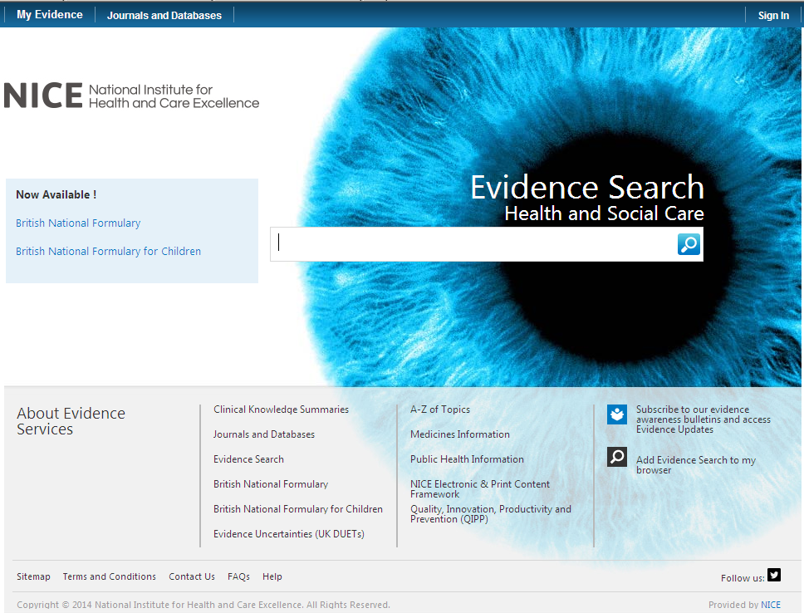

Click on here to sign-in your Athens account

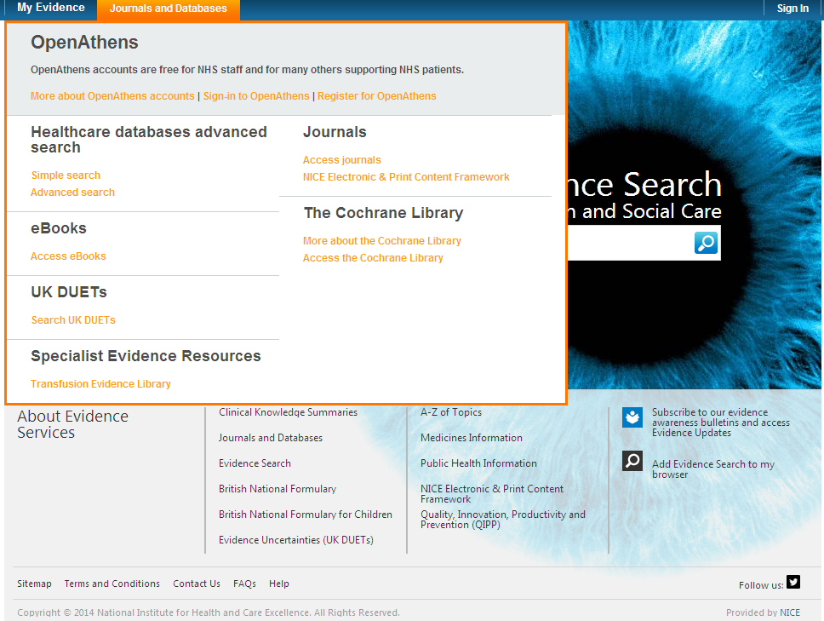

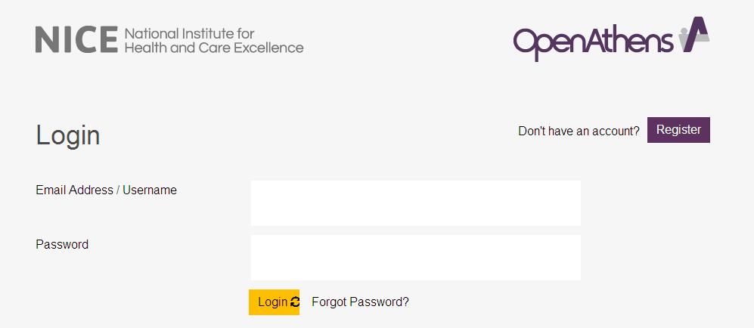

Click on My resources and then click on NICE Journals

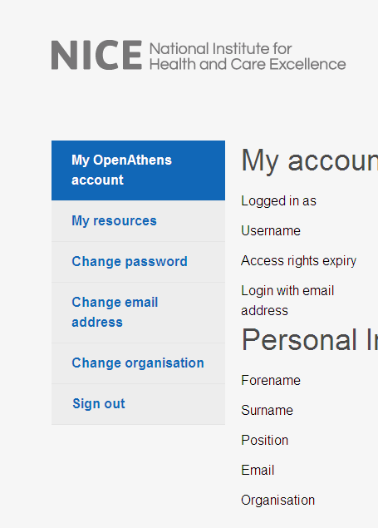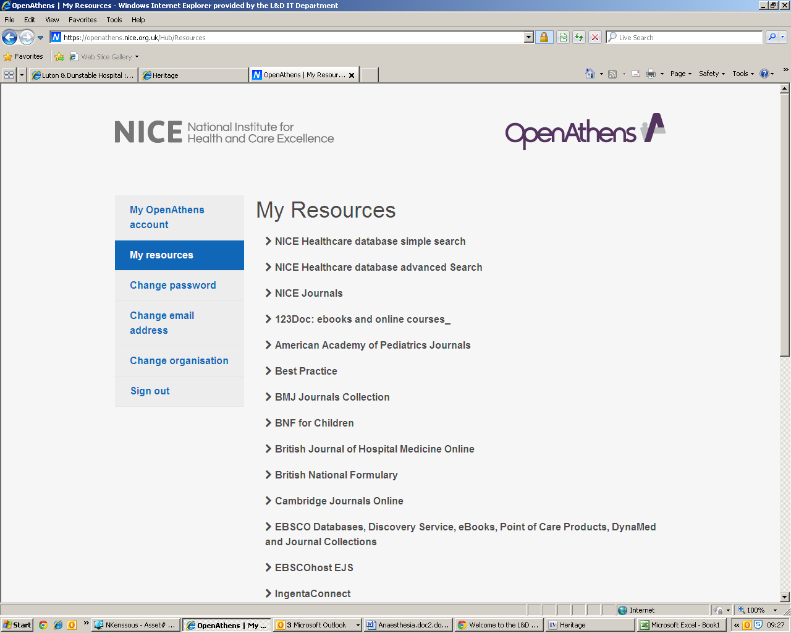

You can browse the A-Z listing, but a more efficient method is to search for the title or keywords from the title of the journal. Enter the title or Key words from the title of the journal you are looking for (e.g. Otolaryngology)

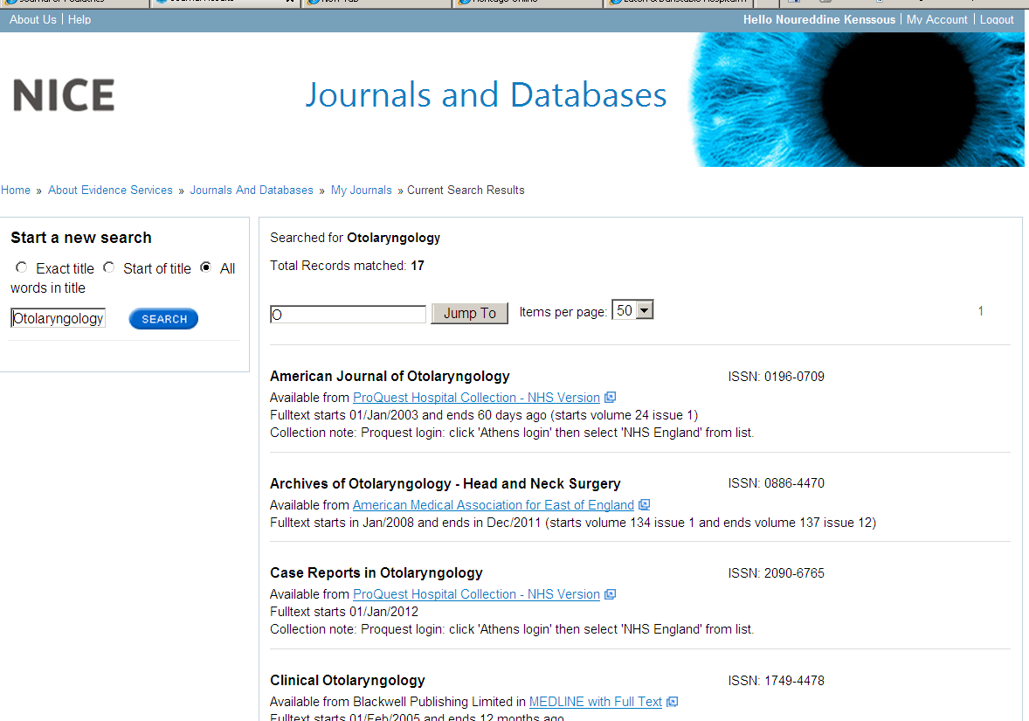

Watch this film for further information on how to access the journals.

- Sources of evidence

Some of the following resources are freely available via www.eel.nhs.uk. Others are accessible with a Luton & Dunstable Hospital NHS Athens account.

BMJ Best Practice (NHS Athens account required)
Point of care resource providing a single source for the latest research evidence, guidelines and expert opinion presented in a step-by-step approach, covering prevention, diagnosis, treatment and prognosis, including additional content from Clinical Evidence. http://bestpractice.bmj.com/best-practice/welcome.html

Cochrane Library
The Cochrane Library is a key source of information on the effects of interventions in health care. It is designed to provide information and evidence to support decisions taken in health care. http://www.thecochranelibrary.com/view/0/index.html

NHS Evidence
Built around a powerful search engine, provides access to the best evidence based resources, especially good for guidelines and reviews. http://www.evidence.nhs.uk/

UptoDate (NHS Athens account required)
A primary resource for medical knowledge at the point of care. UpToDate presents a comprehensive synthesis of the evidence, followed by recommendations that can be acted on at the point of care. http://www.uptodate.com/home

BMJ Case Reports (NHS Athens account required)
An award winning journal that delivers a focused, peer-reviewed, valuable collection of cases in all disciplines so that healthcare professionals, researchers and others can easily find clinically important information on common and rare conditions. Ask the library for the fellowship code if you wish to publish a paper in BMJ Case Reports. http://casereports.bmj.com/

Royal Marsden Manual Online (NHS Athens account required)
The Manual includes over 350 evidence-based clinical procedures related to every aspect of care, from hand washing to cardiopulmonary resuscitation. http://www.rmmonline.co.uk/

NHS Athens accounts
Registering for an Athens account is straightforward, it requires two easy steps: registration and activation. You can begin from the East of England Health Libraries website: www.eel.nhs.uk/ if you register for an Athens account from an NHS computer with an NHS mail address you’ll receive an Athens username straight away. If you register from any other computer, using any other type of email address, it can take longer; up to 15 days in exceptional circumstances as your details need to be verified.

https://register.athensams.net/nhs/nhseng/

The COMET Library

- The COMET Library is located in the main building in Luton and Dunstable Hospital - it is on the first floor of the Centre for Multiprofessional Education and Training.
- It offers a quiet area for study with several study units and easy chair with a suite of fourteen computers which have access to the internet but are not on the NHS network.
- Inductions and full information on library services are offered to all new members.
- There are workshops and one to ones available for literature searching – book an appointment if you are interested.
- You can complete a registration form via the website or you can sign up in person at the library. You will need proof of your employing organisation. Students on placement will need to show their university ID.
  - You can borrow up to eight books at any one time
  - The usual loan period is three week
  - Books can be renewed if no one else wants to borrow them
  - Books can be posted out to your workplace if you are not able to visit

- The library operates a self service unit so items can be borrowed, returned and renewed twenty four seven. But you can also manage your own loans, requests, renewals, with your borrower car, user ID and PIN using the online catalogue.

- You can suggest books for us to buy and request books that are not in stock.
- You do not need to visit the library to borrow resources; we can post items to your workplace.
- You will need an Athens Account to download full text articles but do request items that you cannot obtain for yourself
  - We’ll try and obtain items within the regional network so no direct charges are necessary but if a cost is incurred we will consult you before requesting the book or article.
  - Most requests arrive within a few days of ordering, but if you need your item by a certain date, please tell us this when you make the request.
For more information about The COMET Library call, email or visit our website: www.ldh.nhs.uk/library_services.htm

