The COMET Library

Email: library@ldh.nhs.uk –Tel: 01582 497201

Web: www.ldh.nhs.uk/library_services.htm

Elderly Medicine
Subject guide: print and electronic resources

- Books

Recently purchased books

Elderly care exams WT 18
Forsyth, D. and Wallis, S. (2014) Best of five MCQs for the geriatric medicine SCE. OUP.
9780199651603

Gabriel, R. (2012) MCQs in geriatric medicine for postgraduate examinations. London: Radcliffe. (MasterPass). 9781846195761

Elderly medicine WT 100
Bowker, L.K. and Price, J.D. (2012) Oxford handbook of geriatric medicine. Oxford: Oxford University Press. 9780199586097

Gosney, M., Harper, A. and Conroy, S. (eds.) (2012) Geriatric medicine. Oxford: Oxford University Press. (Oxford desk reference). 9780199592340

Woodford, H. and George, j. (no date) Acute medicine in the frail elderly. Radcliffe. 9781908911582

Location of books in the library Classmark

Elderly exams WT 18
Elderly ethics WT 21
Elderly abuse WT 30
Elderly care services WT 31
Elderly medicine WT 100
Elderly nutrition WT 115
Elderly health promotion WT 116
Elderly mental health services WT 145
Elderly psychiatry WT 150

A full list of books on Elderly medicine is available from the online library catalogue: http://thecometlibrary.nhslibraries.com/

eBooks (available with NHS Athens account)
These are available through NHS Evidence when logged in with your Athens account, from here: http://www.library.nhs.uk/booksandjournals/ebooks/default.aspx.

Blackburn, J.A. and Dulmus, C. N., 2007. Handbook of Gerontology.[online]. Wiley.
9780470125717

Bracewell, C., Gray, R. and Rai, G.S., 2005. Essential facts in geriatric medicine. [online]. Radcliffe Publishing.
9781857758672

Pathy, M.S., Sinclair, A.J. and Morley, J.E., 2006. Principles and practice of geriatric medicine. 4th ed. [online]. Wiley.
9780470090565

Rai, G., 2009. Medical ethics and the elderly. 3rd ed. [online]. Radcliffe Publishing.
9781846193071

- Journals

Print journals in the library

CME Journal – Geriatric Medicine from 2013
eJournals (available with NHS Athens account)

American Journal of Geriatric Cardiology 2003 to 2008 v 17(1)

Dementia and Geriatric Cognitive Disorders 1998 to 12 months ago

International Journal of Geriatric Psychiatry 1997 to 12 months ago

Age 1997 to 12 months ago

Age and Ageing 1996 to current issue

Aging 2009 to Nov 2012

Aging and Mental Health 1997 to 18 months ago

Aging Cell 2003 to 12 months

Aging Male 2003 to 18 months ago

Clinical Interventions in Aging 2006 to current issue

Drugs and Aging 1998 to 6 months ago

Experimental Aging Research 1998 to 18 months ago

Frontiers in Aging Neuroscience 2009 to current issue

International Journal of Aging & Human Development 2003 to 6 months ago

Journal of Aging Research 2010 to current issue

Journal of Women and Aging 2000 to current issue

Try This: Best Practices in Nursing Care to Older Adults with Dementia 1998 to current issue

eJournals (available with NHS Athens account)

These are available through NHS Evidence when logged in with your Athens account, from here: http://www.library.nhs.uk/booksandjournals/journals/

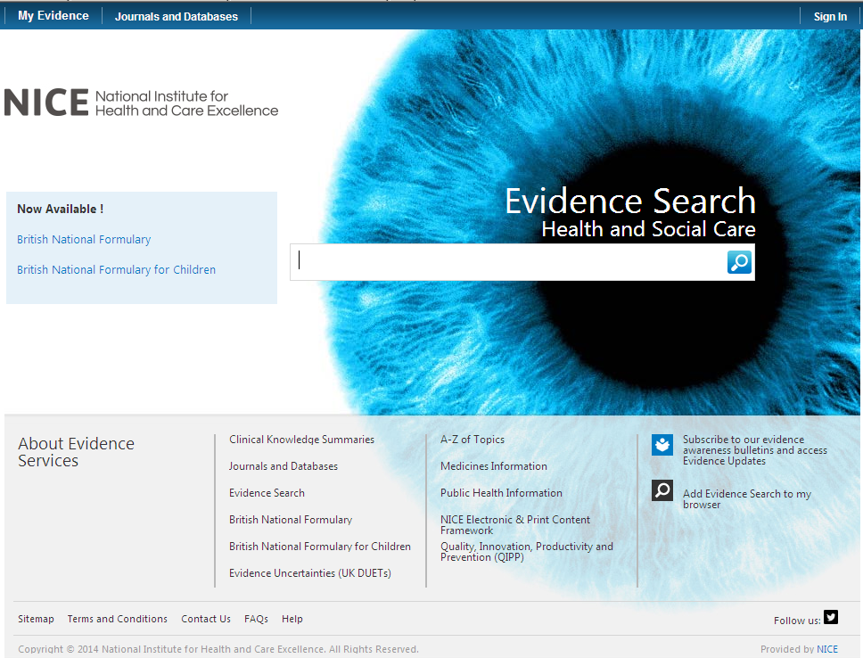

Click on here to sign-in your Athens account

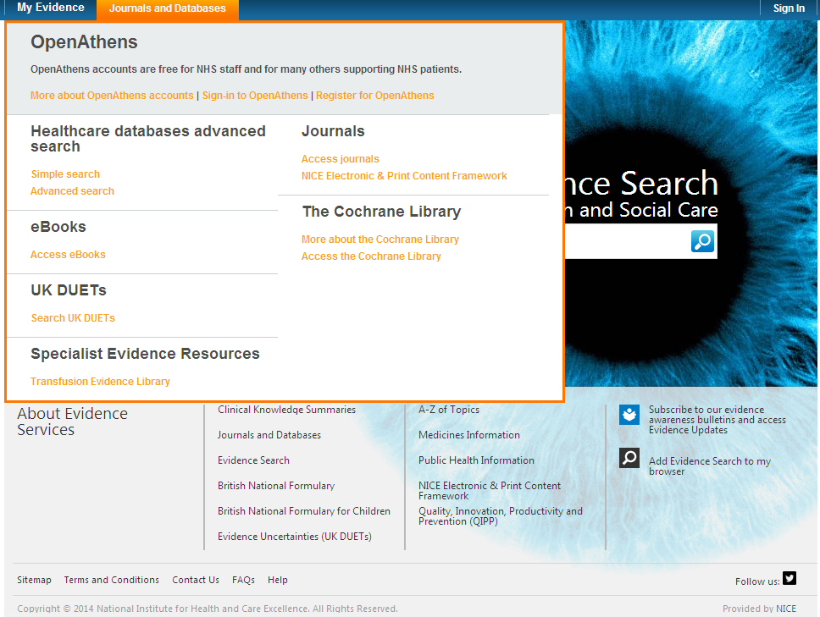

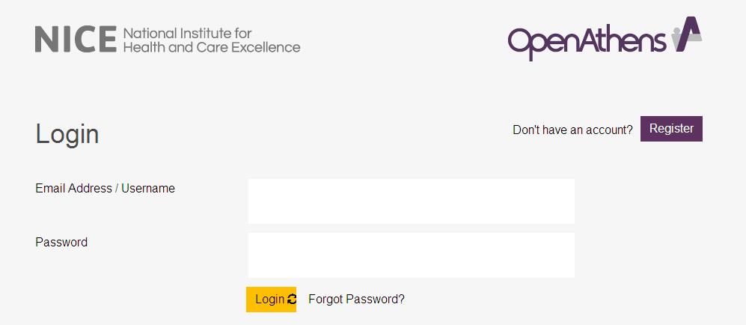

Click on My resources and then click on NICE Journals

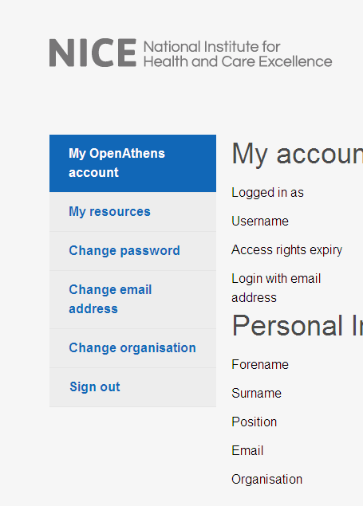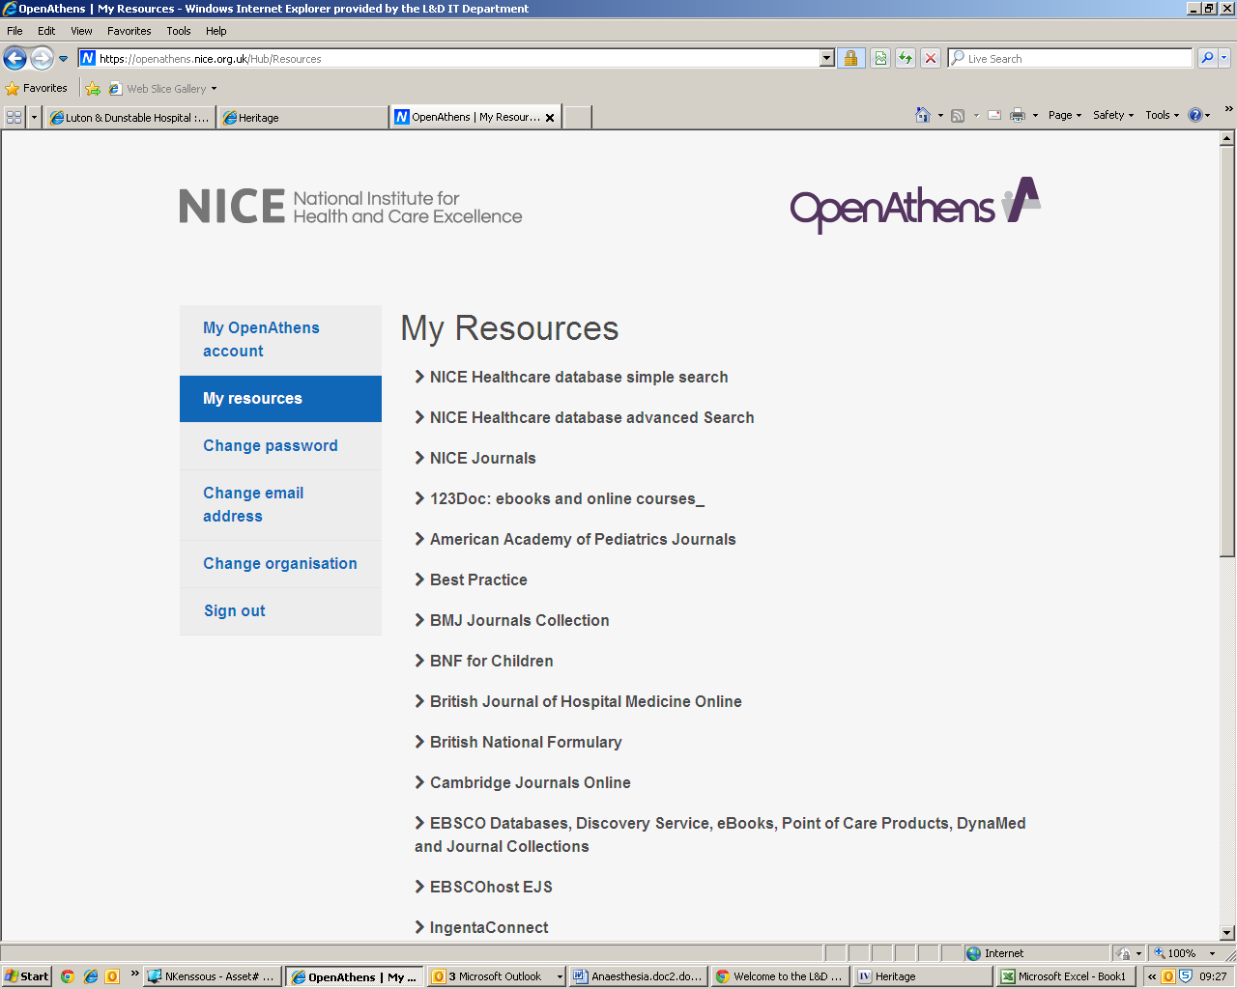

You can browse the A-Z listing, but a more efficient method is to search for the title or keywords from the title of the journal. Enter the title or Key words from the title of the journal you are looking for (e.g. Geriatric)

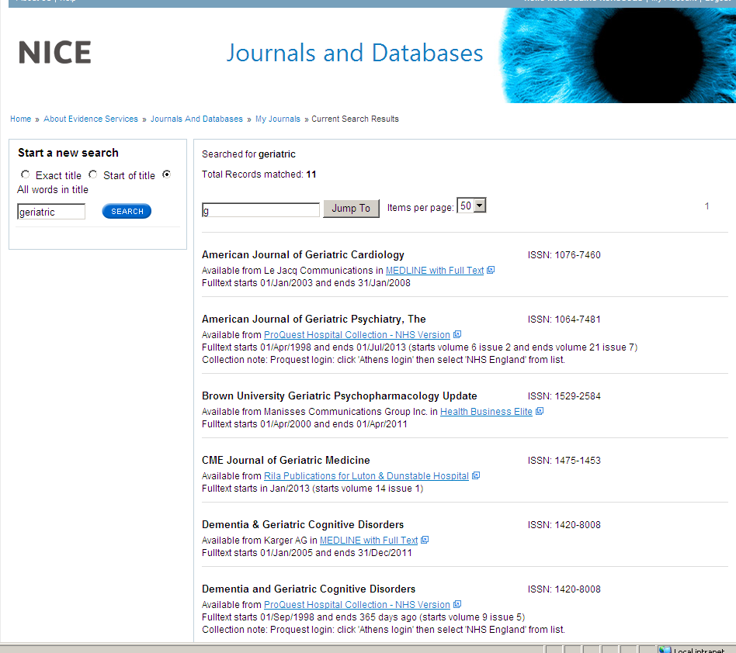

Watch this film for further information on how to access the journals.
- Sources of evidence

Some of the following resources are freely available via www.eel.nhs.uk. Others are accessible with a Luton & Dunstable Hospital NHS Athens account.

BMJ Best Practice (NHS Athens account required)
Point of care resource providing a single source for the latest research evidence, guidelines and expert opinion presented in a step-by-step approach, covering prevention, diagnosis, treatment and prognosis, including additional content from Clinical Evidence. http://bestpractice.bmj.com/best-practice/welcome.html

Cochrane Library
The Cochrane Library is a key source of information on the effects of interventions in health care. It is designed to provide information and evidence to support decisions taken in health care. http://www.thecochranelibrary.com/view/0/index.html

NHS Evidence
Built around a powerful search engine, provides access to the best evidence based resources, especially good for guidelines and reviews. http://www.evidence.nhs.uk/

UptoDate (NHS Athens account required)
A primary resource for medical knowledge at the point of care. UpToDate presents a comprehensive synthesis of the evidence, followed by recommendations that can be acted on at the point of care. http://www.uptodate.com/home

BMJ Case Reports (NHS Athens account required)
An award winning journal that delivers a focused, peer-reviewed, valuable collection of cases in all disciplines so that healthcare professionals, researchers and others can easily find clinically important information on common and rare conditions. Ask the library for the fellowship code if you wish to publish a paper in BMJ Case Reports. http://casereports.bmj.com/

Royal Marsden Manual Online (NHS Athens account required)
The Manual includes over 350 evidence-based clinical procedures related to every aspect of care, from hand washing to cardiopulmonary resuscitation. http://www.rmmonline.co.uk/

NHS Athens accounts
Registering for an Athens account is straightforward, it requires two easy steps: registration and activation. You can begin from the East of England Health Libraries website: www.eel.nhs.uk/ if you register for an Athens account from an NHS computer with an NHS mail address you’ll receive an Athens username straight away. If you register from any other computer, using any other type of email address, it can take longer; up to 15 days in exceptional circumstances as your details need to be verified.

https://register.athensams.net/nhs/nhseng/

The COMET Library

- The COMET Library is located in the main building in Luton and Dunstable Hospital - it is on the first floor of the Centre for Multiprofessional Education and Training.
- It offers a quiet area for study with several study units and easy chair with a suite of fourteen computers which have access to the internet but are not on the NHS network.
- Inductions and full information on library services are offered to all new members.
- There are workshops and one to ones available for literature searching – book an appointment if you are interested.
- You can complete a registration form via the website or you can sign up in person at the library. You will need proof of your employing organisation. Students on placement will need to show their university ID.
  - You can borrow up to eight books at any one time
  - The usual loan period is three week
  - Books can be renewed if no one else wants to borrow them
  - Books can be posted out to your workplace if you are not able to visit

- The library operates a self service unit so items can be borrowed, returned and renewed twenty four seven. But you can also manage your own loans, requests, renewals, with your borrower car, user ID and PIN using the online catalogue.

- You can suggest books for us to buy and request books that are not in stock.
- You do not need to visit the library to borrow resources; we can post items to your workplace.
- You will need an Athens Account to download full text articles but do request items that you cannot obtain for yourself
  - We’ll try and obtain items within the regional network so no direct charges are necessary but if a cost is incurred we will consult you before requesting the book or article.
  - Most requests arrive within a few days of ordering, but if you need your item by a certain date, please tell us this when you make the request.
For more information about The COMET Library call, email or visit our website: www.ldh.nhs.uk/library_services.htm

