The COMET Library

Email: library@ldh.nhs.uk –Tel: 01582 497201

Web: www.ldh.nhs.uk/library_services.htm

Neonatology
Subject guide: print and electronic resources

- Books

Recently purchased books

Neonatal physiology WQ 210
Blackburn, S.T. (2013) Maternal, fetal, & neonatal physiology: a clinical perspective. 4th ed. Maryland Heights, USA: Elsevier. 9781437716238

Moore, K.L., Persaud, T.V.N. and Torchia, M.G. (2013) The developing human: clinically oriented embryology. 9th ed. Philadelphia, PA: Saunders/Elsevier. 9781437720020

Neonatal Care WS 420
Cloherty, J., Eichenwald, E. and Hansen, A. (eds.) (2012) Manual of neonatal care. 7th ed. Philadelphia, USA: Lippincott, Williams & Wilkins. 9781451118117

Fanaroff, A.A., Fanaroff, J.M. and Klaus, M.H. (2013) Klaus & Fanaroff's care of the high-risk neonate. 6th ed. Philadelphia, USA: Saunders. 9781416040019

Gomella, T.L., Cunningham, D.M. and Eyal, F.G. (eds.) (2013) Neonatology: management, procedures, on-call problems, diseases and drugs. 7th ed. London: McGraw-Hill. 9780071768016

MacDonald, M., Ramasethu, J. and Rais-Bahrami, K. (eds.) (2013) Atlas of procedures in neonatology. 5th ed. Philadelphia, USA: Lippincott Williams & Wilkins. 9781451144109

Sinha, S., Miall, L. and Jardine, u. (2012) Essential neonatal medicine. 5th ed. Chichester: Wiley-Blackwell. 9780470670408

Developmental defects WS 421
Holmes, L.B. (2012) Common malformations. Oxford: Oxford University Press. 9780195136029

Location of books in the library Classmark

Neonatal physiology WQ 210
Death (SIDS) WS 405
Premature births WS 410
Neonatal care WS 420
Developmental defects WS 421

A full list of books on Neonatology is available from the online library catalogue: http://thecometlibrary.nhslibraries.com/

eBooks (available with NHS Athens account)
These are available through NHS Evidence when logged in with your Athens account, from here: http://www.library.nhs.uk/booksandjournals/ebooks/default.aspx.

- Baston, H., 2000. Examination of the newborn: a practical guide. [online]. Taylor & Francis.
- Watkinson, M., 2005. Key topics in neonatology. 2nd ed. [online] . Taylor & Francis.

- Journals

Print journals in the library

Clinics in Perinatology 1992 to 2004, 2007 to 2011
eJournals (available with NHS Athens account)

These are available through NHS Evidence when logged in with your Athens account, from here: http://www.library.nhs.uk/booksandjournals/journals/

Archives of Disease in Childhood - Fetal and Neonatal Edition 1994 to current issue

Journal of Maternal-Fetal & Neonatal Medicine 2004 to 18 months ago

Journal of Obstetric, Gynecologic & Neonatal Nursing 2006 to 12 months ago

Neonatal, Paediatric & Child Health Nursing 2006 to 6 months ago

Neonatology 1998 to 12 months ago

Seminars in Fetal & Neonatal Medicine 2007 to current issue

eJournals (available with NHS Athens account)

These are available through NHS Evidence when logged in with your Athens account, from here: http://www.library.nhs.uk/booksandjournals/journals/

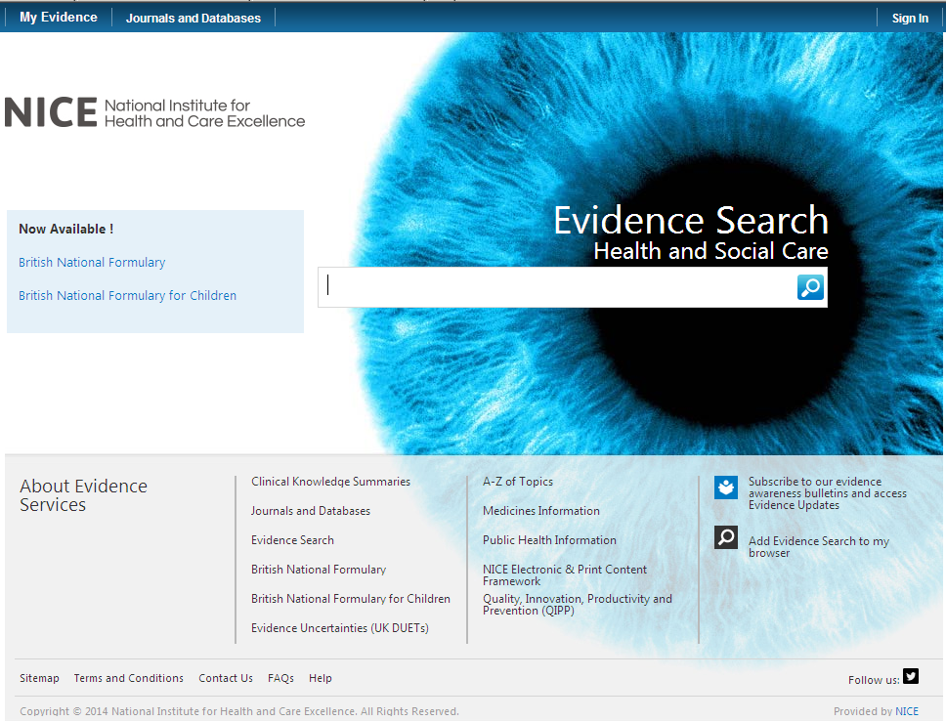

Click on here to sign-in your Athens account

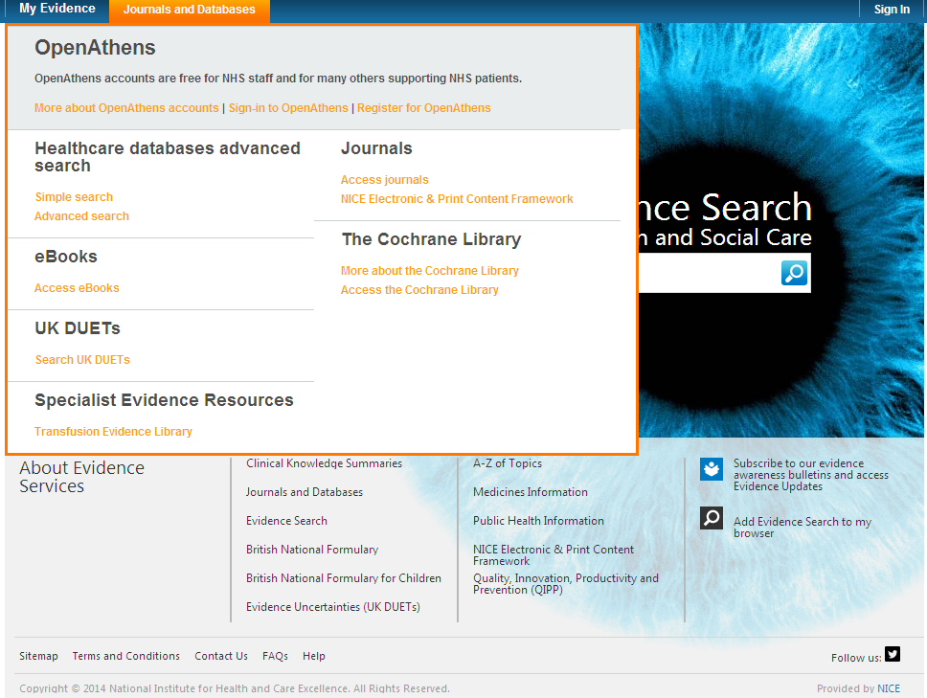

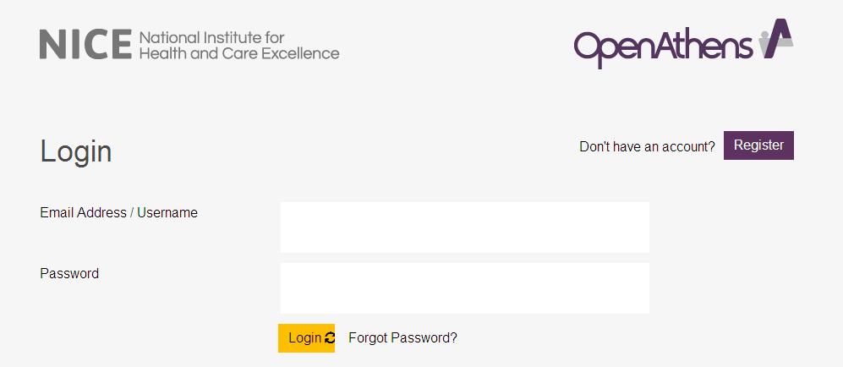

Click on My resources and then click on NICE Journals

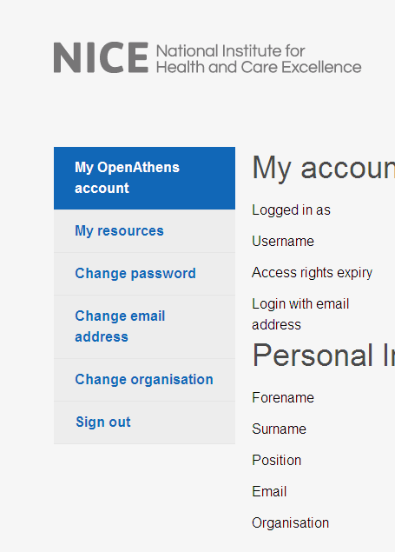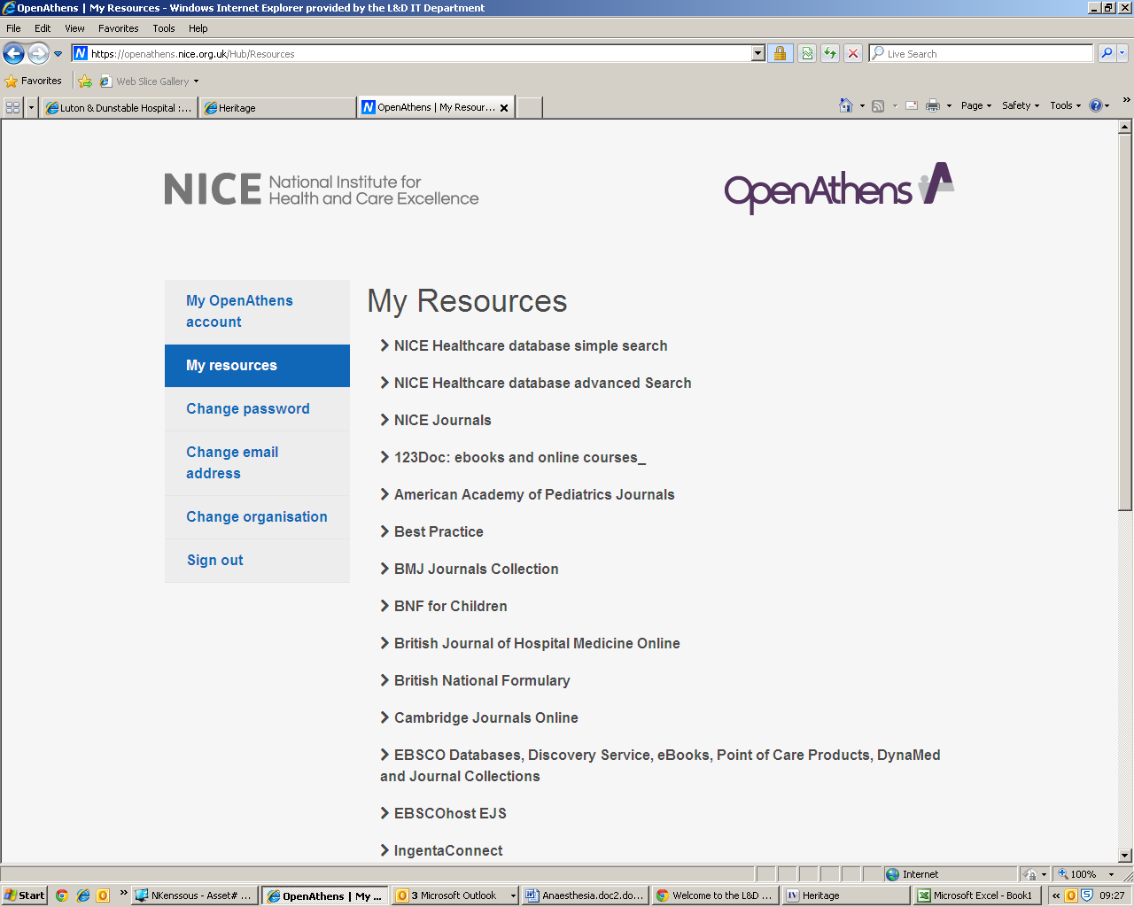

You can browse the A-Z listing, but a more efficient method is to search for the title or keywords from the title of the journal. Enter the title or Key words from the title of the journal you are looking for (e.g.Neonatal)

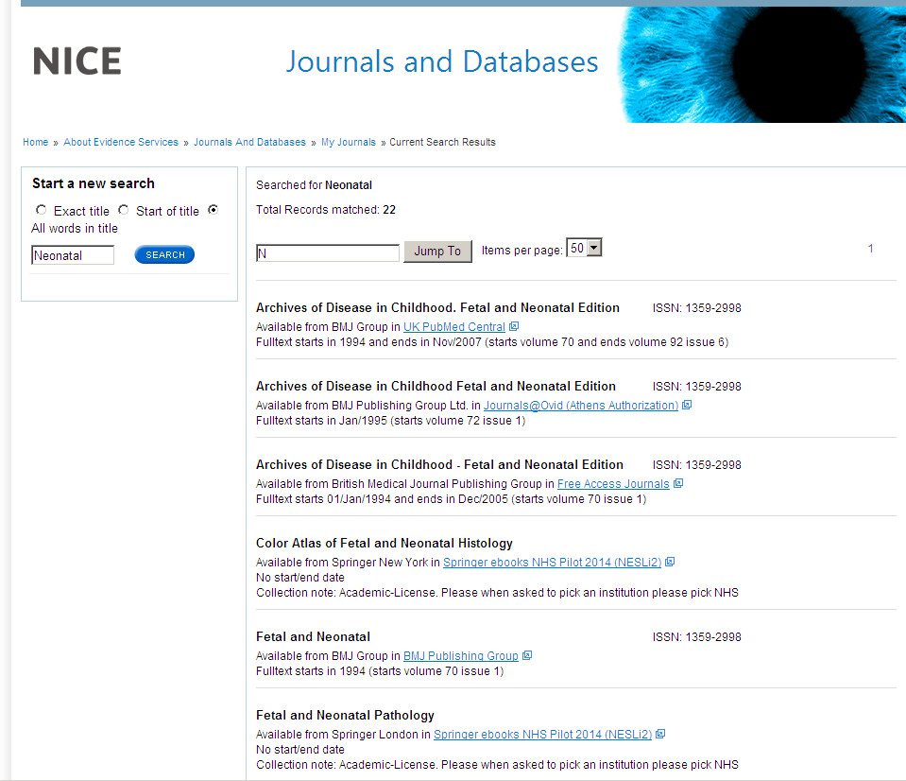

Watch this film for further information on how to access the journals.
- Sources of evidence

Some of the following resources are freely available via www.eel.nhs.uk. Others are accessible with a Luton & Dunstable Hospital NHS Athens account.

BMJ Best Practice (NHS Athens account required)
Point of care resource providing a single source for the latest research evidence, guidelines and expert opinion presented in a step-by-step approach, covering prevention, diagnosis, treatment and prognosis, including additional content from Clinical Evidence. http://bestpractice.bmj.com/best-practice/welcome.html

Cochrane Library
The Cochrane Library is a key source of information on the effects of interventions in health care. It is designed to provide information and evidence to support decisions taken in health care. http://www.thecochranelibrary.com/view/0/index.html

NHS Evidence
Built around a powerful search engine, provides access to the best evidence based resources, especially good for guidelines and reviews. http://www.evidence.nhs.uk/

UptoDate (NHS Athens account required)
A primary resource for medical knowledge at the point of care. UpToDate presents a comprehensive synthesis of the evidence, followed by recommendations that can be acted on at the point of care. http://www.uptodate.com/home

BMJ Case Reports (NHS Athens account required)
An award winning journal that delivers a focused, peer-reviewed, valuable collection of cases in all disciplines so that healthcare professionals, researchers and others can easily find clinically important information on common and rare conditions. Ask the library for the fellowship code if you wish to publish a paper in BMJ Case Reports. http://casereports.bmj.com/

Royal Marsden Manual Online (NHS Athens account required)
The Manual includes over 350 evidence-based clinical procedures related to every aspect of care, from hand washing to cardiopulmonary resuscitation. http://www.rmmonline.co.uk/

NHS Athens accounts
Registering for an Athens account is straightforward, it requires two easy steps: registration and activation. You can begin from the East of England Health Libraries website: www.eel.nhs.uk/ if you register for an Athens account from an NHS computer with an NHS mail address you’ll receive an Athens username straight away. If you register from any other computer, using any other type of email address, it can take longer; up to 15 days in exceptional circumstances as your details need to be verified.

https://register.athensams.net/nhs/nhseng/

The COMET Library

- The COMET Library is located in the main building in Luton and Dunstable Hospital - it is on the first floor of the Centre for Multiprofessional Education and Training.
- It offers a quiet area for study with several study units and easy chair with a suite of fourteen computers which have access to the internet but are not on the NHS network.
- Inductions and full information on library services are offered to all new members.
- There are workshops and one to ones available for literature searching – book an appointment if you are interested.
- You can complete a registration form via the website or you can sign up in person at the library. You will need proof of your employing organisation. Students on placement will need to show their university ID.
  - You can borrow up to eight books at any one time
  - The usual loan period is three week
  - Books can be renewed if no one else wants to borrow them
  - Books can be posted out to your workplace if you are not able to visit

- The library operates a self service unit so items can be borrowed, returned and renewed twenty four seven. But you can also manage your own loans, requests, renewals, with your borrower car, user ID and PIN using the online catalogue.

- You can suggest books for us to buy and request books that are not in stock.
- You do not need to visit the library to borrow resources; we can post items to your workplace.
- You will need an Athens Account to download full text articles but do request items that you cannot obtain for yourself
  - We’ll try and obtain items within the regional network so no direct charges are necessary but if a cost is incurred we will consult you before requesting the book or article.
  - Most requests arrive within a few days of ordering, but if you need your item by a certain date, please tell us this when you make the request.
For more information about The COMET Library call, email or visit our website: www.ldh.nhs.uk/library_services.htm

