The COMET Library

Email: library@ldh.nhs.uk –Tel: 01582 497201

Web: www.ldh.nhs.uk/library_services.htm

Neurology
Subject guide: print and electronic resources

- Books

Recently purchased books

Neurology exams WL 18

Natalwala, I. and natawala, A. (2014) MCQ'S in neurology and neurosurgery for medical students. London: Radcliffe Publishing Ltd. 9781846194832

Neurological diagnosis WL 141
Fuller, G. (2013) Neurological examination made easy. 5th ed. Edinburgh: Churchill Livingstone. 9780702051777

Headaches WL 342
Maggiore, S. and Maggiore, J. (2013) Migraine treatments and remedies. CreateSpace Independent Publishing Platform. (What if it's...). 9781481924122

Sacks, O. (2012) Migraine. London: Picador. 9780330526142

Neurological rehabilitation WL 355
Pendlebury, S. Schultz, Malhotra, A. and Rothwell, P.M. (2012) Oxford case histories in TIA and stroke. Oxford: Oxford University Press. 9780199539345

Torbey, M.T. and Selim, M.H. (eds.) (2013) The stroke book. 2nd ed. Cambridge: Cambridge University Press. 9781107634725

Pain Management WL 704
Colvin, L. and Fallon, M. (eds.) (2012) ABC of pain. Chichester: Wiley-Blackwell. (ABC Series). 9781405176217

Simpson, K., Baranidharan, G. and Gupta, S. (2012) Oxford handbook of spinal interventions in pain management. Oxford: Oxford University Press. (Oxford specialist handbooks). 9780199586912
Location of books in the library Classmark

Neurology atlases WL 17
Neurology exams WL 18
Neurology WL 100
Neuroanatomy WL 101
Neurophysiology WL 102
Neuropsychology WL 103.5
Neuropathology WL 140
Neurological diagnosis WL 141
Central nervous system WL 300
Brainstem death WL 310
Headaches WL 342
Paralysis WL 346
Neurological rehabilitation WL 355
Degenerative Disorders (Parkinsonism) WL 359
Multiple sclerosis WL 360
Neurosurgery WL 368
Epilepsy WL 380
Spinal cord injuries WL 400
Pain management WL 704

A full list of books on Neurology is available from the online library catalogue: http://thecometlibrary.nhslibraries.com/

eBooks (available with NHS Athens account)
These are available through NHS Evidence when logged in with your Athens account, from here: http://www.library.nhs.uk/booksandjournals/ebooks/default.aspx.

- Helmy, S.W., 2004. 1000 EMQ's for PLAB based on current exams. [online]. Radcliffe Publishing.

- Pattison, J and Williams, G., 2007. 100 cases in clinical medicine. 2nd ed. [online]. Taylor & Francis.

- Simon, C., Everitt, H. and Kendrick, T., 2005. Oxford handbook of general practice. [online]. Oxford University Press.

- Stephenson, A., 2004. A textbook of general practice. 2nd ed. [online]. Taylor & Francis.

Stephenson, A. and Mueller, M., 2009. 100 cases in general practice. [online]. Taylor & Francis.
2. Journals

Print journals in the library

Neurology 2006 to 2011

eJournals (available with Athens account)

Annals of Neurology 1996 to current issue

Annals of Indian Academy of Neurology 2008 to current issue

Archives of Neurology 2008 to 2011

Behavioural Neurology 2001 to 12 months ago

BMC Neurology 2001 to current issue

Canadian Journal of Neurological Sciences 2007 to current issue

Cardiovascular Psychiatry and Neurology 2009 to current issue

Case Reports in Neurology 2009 to current issue

CNS and Neurological Disorders - Drug Targets 2006 to 12 months ago

Cognitive and Behavioral Neurology 2001 to 2005

Current Neurology and Neuroscience Reports 2001 to 12 months ago

Current Opinion in Neurology 1998 to current issue

Developmental Medicine and Child Neurology 2006 to 12 months ago

European Journal of Neurology 2000 to 12 months ago

European Neurological Journal 2009 to 2011

European Neurology 1998 to 12 months ago

Frontiers in Neurology 2010 to current issue

Functional Neurology 2006 to 2012

Future Neurology 2006 to current issue

Journal of Child Neurology 2001 to 2006

Journal of Clinical Neurology 2005 to current issue

Journal of Neurology 1999 to 12 months ago

Journal of Neurology and Psychiatry 1938 to 1944

Journal of Neurology and Psychopathology 1920 to 1937

Journal of Neurology, Neurosurgery and Psychiatry 1920 to current issue

Journal of Neuropathology and Experimental Neurology 1997 to current issue

Journal of Pediatric Neurology 2004 to 2012

Lancet Neurology 2002 to current issue

Neurological Research 2005 to 12 months ago

Neurological Sciences 2000 to 12 months ago

Neurology 1995 to 2012

Neurology Alert 2008 to current issue

Neurology Coding Alert 2010 to current issue

Neurology India 2003 to current issue

Neurology Research International 2010 to current issue

Open Neurology Journal 2007 to current issue

Practical Neurology 2001 to 2005

Restorative Neurology and Neuroscience 2001 to 12 months ago

Surgical Neurology International 2010 to current issue

Therapeutic Advances in Neurological Disorders 2008 to current issue

eJournals (available with NHS Athens account)

These are available through NHS Evidence when logged in with your Athens account, from here: http://www.library.nhs.uk/booksandjournals/journals/

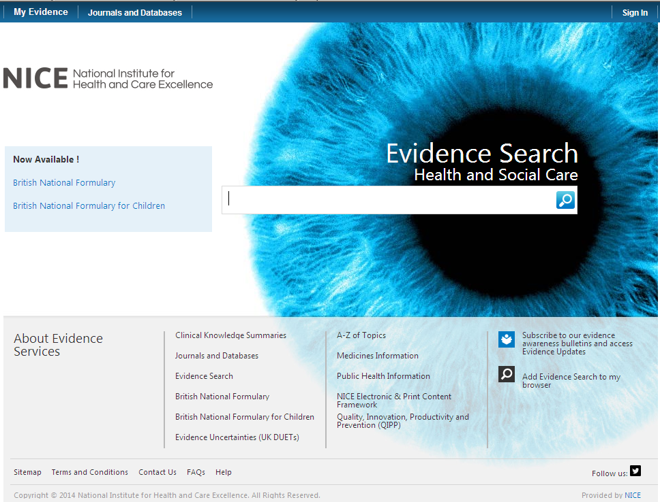

Click on here to sign-in your Athens account

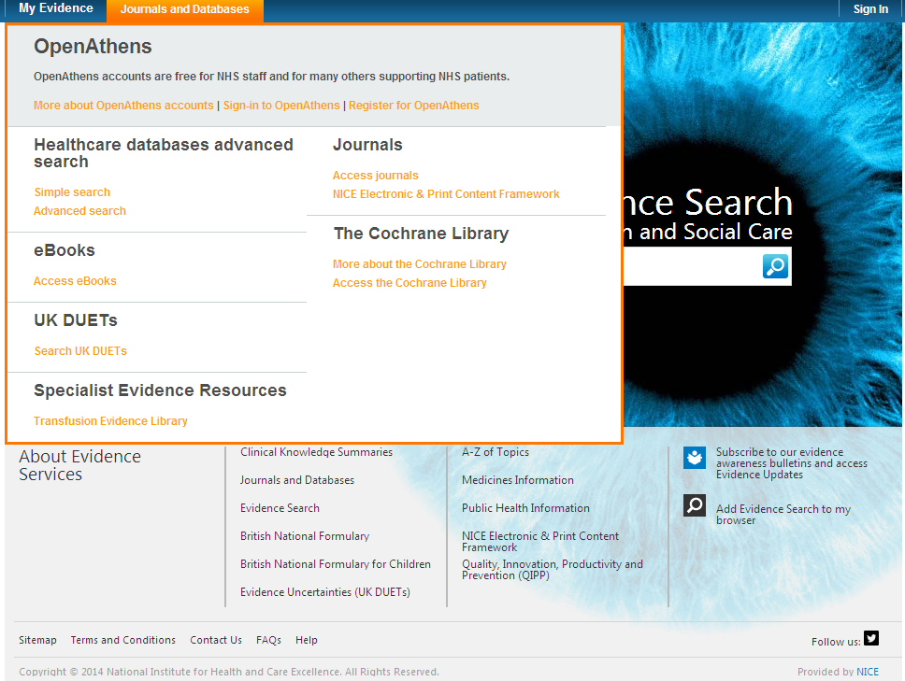

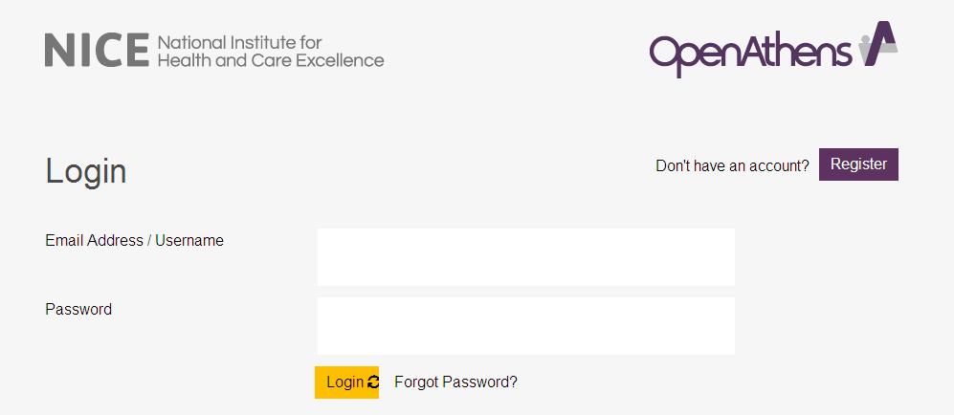

Click on My resources and then click on NICE Journals

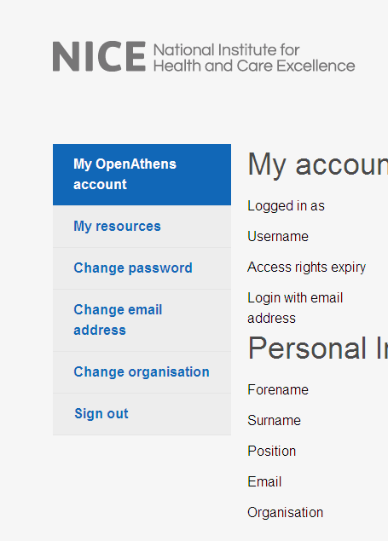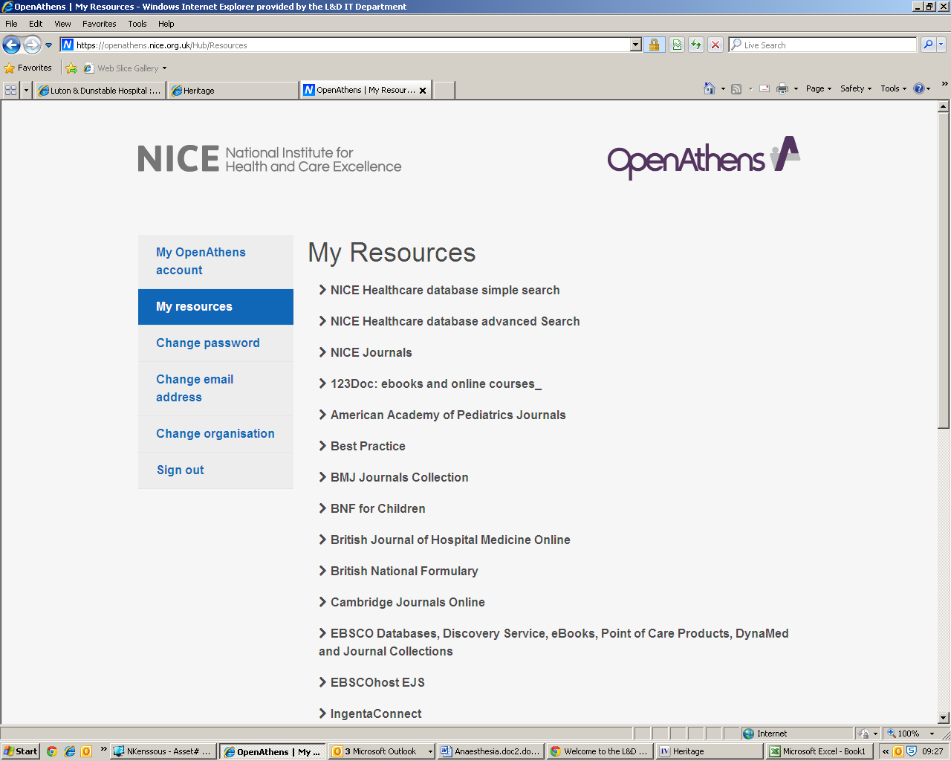

You can browse the A-Z listing, but a more efficient method is to search for the title or keywords from the title of the journal. Enter the title or Key words from the title of the journal you are looking for (e.g. Cardiology)

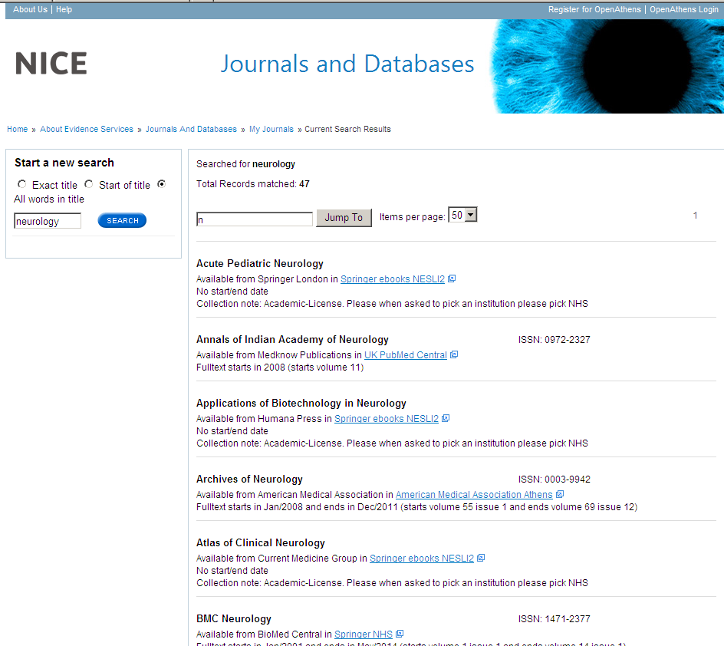

Watch this film for further information on how to access the journals.

3. Sources of evidence

Some of the following resources are freely available via www.eel.nhs.uk. Others are accessible with a Luton & Dunstable Hospital NHS Athens account.

BMJ Best Practice (NHS Athens account required)
Point of care resource providing a single source for the latest research evidence, guidelines and expert opinion presented in a step-by-step approach, covering prevention, diagnosis, treatment and prognosis, including additional content from Clinical Evidence. http://bestpractice.bmj.com/best-practice/welcome.html

Cochrane Library
The Cochrane Library is a key source of information on the effects of interventions in health care. It is designed to provide information and evidence to support decisions taken in health care. http://www.thecochranelibrary.com/view/0/index.html

NHS Evidence
Built around a powerful search engine, provides access to the best evidence based resources, especially good for guidelines and reviews. http://www.evidence.nhs.uk/

UptoDate (NHS Athens account required)
A primary resource for medical knowledge at the point of care. UpToDate presents a comprehensive synthesis of the evidence, followed by recommendations that can be acted on at the point of care. http://www.uptodate.com/home

BMJ Case Reports (NHS Athens account required)
An award winning journal that delivers a focused, peer-reviewed, valuable collection of cases in all disciplines so that healthcare professionals, researchers and others can easily find clinically important information on common and rare conditions. Ask the library for the fellowship code if you wish to publish a paper in BMJ Case Reports. http://casereports.bmj.com/

Royal Marsden Manual Online (NHS Athens account required)
The Manual includes over 350 evidence-based clinical procedures related to every aspect of care, from hand washing to cardiopulmonary resuscitation. http://www.rmmonline.co.uk/

NHS Athens accounts
Registering for an Athens account is straightforward, it requires two easy steps: registration and activation. You can begin from the East of England Health Libraries website: www.eel.nhs.uk/ if you register for an Athens account from an NHS computer with an NHS mail address you’ll receive an Athens username straight away. If you register from any other computer, using any other type of email address, it can take longer; up to 15 days in exceptional circumstances as your details need to be verified.

https://register.athensams.net/nhs/nhseng/

https://register.athensams.net/nhs/nhseng/

The COMET Library

- The COMET Library is located in the main building in Luton and Dunstable Hospital - it is on the first floor of the Centre for Multiprofessional Education and Training.
- It offers a quiet area for study with several study units and easy chair with a suite of fourteen computers which have access to the internet but are not on the NHS network.
- Inductions and full information on library services are offered to all new members.
- There are workshops and one to ones available for literature searching – book an appointment if you are interested.
- You can complete a registration form via the website or you can sign up in person at the library. You will need proof of your employing organisation. Students on placement will need to show their university ID.
  - You can borrow up to eight books at any one time
  - The usual loan period is three week
  - Books can be renewed if no one else wants to borrow them
  - Books can be posted out to your workplace if you are not able to visit

- The library operates a self service unit so items can be borrowed, returned and renewed twenty four seven. But you can also manage your own loans, requests, renewals, with your borrower car, user ID and PIN using the online catalogue.

- You can suggest books for us to buy and request books that are not in stock.
- You do not need to visit the library to borrow resources; we can post items to your workplace.
- You will need an Athens Account to download full text articles but do request items that you cannot obtain for yourself
  - We’ll try and obtain items within the regional network so no direct charges are necessary but if a cost is incurred we will consult you before requesting the book or article.
  - Most requests arrive within a few days of ordering, but if you need your item by a certain date, please tell us this when you make the request.
For more information about The COMET Library call, email or visit our website: www.ldh.nhs.uk/library_services.htm

