The COMET Library

Email: library@ldh.nhs.uk –Tel: 01582 497201

Web: www.ldh.nhs.uk/library_services.htm

Nursing
Subject guide: print and electronic resources

- Books

Recently purchased books

Pharmacology QV 4
Barber, P. and Robertson, D. (2012) Essentials of pharmacology for nurses. 2nd ed. Maidenhead: Open University Press. 9780335245659

Rogers, K.M.A. (2014) Nurses! Test yourself in pharmacology. Maidenhead: Open University Press. 9780335244911

Nursing education WY 18
Hutchfield, K. and Standing, M. (2012) Succeeding in essays, exams and OSCE's for nursing students. London: Sage. 9780857250612

Price, B. and Harrington, A. (2013) Critical thinking and writing for nursing students. 2nd ed. London: Learning Matters. (Transforming nursing practice). 9781446256442

Siviter, B. (2013) The student nurse handbook: a survival guide. 3rd ed. Edinburgh: Baillière Tindall. 9780702045790

Nursing research WY 20.5
Bettany-Saltikov, J. (2012) How to do a systematic literature review in nursing: a step-by-step guide. Maidenhead: Open University Press. 9780335242276

Craig, J.V. and Smyth, R.L. (eds.) (2012) The evidence-based practice manual for nurses. 3rd ed. Edinburgh: Churchill Livingstone.

Langford, R. and Young, A. (2013) Making a difference with nursing research. Boston: Pearson. 9780132343992

LoBiondo-Wood, G. and Haber, J. (2014) Nursing research: methods and critical appraisal for evidence-based practice. 8th ed. Missouri, USA: Elsevier. 9780323100861

Polit, D.F. and Beck, C.T. (2012) Nursing research-generating and assessing evidence for nursing practice. 9th ed. Wolters Kluwer. 9781451109146
Nursing Laws WY 32
Griffith, R.A. and Tengnah, C. (2014) Law and professional issues in nursing. 3rd ed. London: Sage. (Transforming nursingpractice). 9781446268582

Tingle, J. and Cribb, A. editors (2014) Nursing law and ethics. 4th ed. London: Wiley-Blackwell. 9780470671375

Nursing ethics WY 85
Burkhardt, M.A. and Nathaniel, A.K. (2014) Ethics & issues in contemporary nursing. 4th ed. Stamford, US: Cengage Learning. 9781133129165

Melia, K.M. (2014) Ethics for nursing and healthcare practice. London: SAGE. 9780857029300

Models of reflection WY 86
Bulman, C. and Schutz, S. (eds.) (2013) Reflective practice in nursing. 5th ed. Hoboken: Wiley-Blackwell. 9780470658109

Johns, C. (2013) Becoming a reflective practitioner. 4th ed. Chichester: Wiley. 9780470674260

Nursing relationships WY 87
Baughan, J. and Smith, A. (2013) Compassion, caring and communication: skills for nursing practice. 2nd ed. Harlow: Pearson. 9780273769446

Buresh, B. and Gordon, S. (2013) From silence to voice: what nurses know and must communicate to the public. 3rd ed. Cornell University. 9780801478734

Roberts, D. (2013) Psychosocial nursing care: a guide to nursing the whole person. Maidenhaed: Open University. 9780335244140

Nursing procedures WY 100

Baille, L. (2014) Developing practical nursing skills. 4th ed. CRC Press. 9781444175950

Duffy, J.R. (2013) Quality caring in nursing and health systems: implications for clinicians, educators and leaders. 2nd ed. New York: Springer. 9780826110145

Eckman, M. (ed.) (2013) Lippincott's nursing procedures. 6th ed. Philadelphia, USA: Lippincott Williams & Wilkins. 9781451146332

Koutoukidis, G., Stainton, K. and Hughson, J. (2013) Tabbner's nursing care: theory and practice. 6th ed. Churchill Livingstone. 9780729541145

Nettina, S.M. (2014) Lippincott manual of nursing practice. 10th ed. London: Wolters Kluwer/Lippincott Williams & Wilkins. 9781451176483

Ong, P., Garrett, B. and Allen, D. (2012) Clinical pocket reference for nurses. 2nd ed. Abingdon: Marston Book Services. 9780954306595

Care planning WY 100.4
Barrett, D., Wilson, B. and Woollands, A. (2012) Care planning: a guide for nurses. 2nd ed. Harlow, England: Pearson Education. 9780273746119

Gulanick, M. and Myers, J.L. (2014) Nursing care plans: diagnoses, interventions, and outcomes. 8th ed. St Louis, USA: Elsevier. 9780323091374
Howatson-Jones, L., Standing, M. and Roberts, S. (2012) Patient assessment and care planning in nursing. Exeter: Learning Matters. (Transforming nursing practice). 9780857257376

Leadership nursing WY 104
Chambers, C. and Ryder, E. (2012) Excellence in compassionate nursing care: leading the change. Milton Keynes, Radcliffe. 9781846193996

Huber, D. (2014) Leadership and nursing care management. 5th ed. Elsevier Saunders. 9781455740710

Sullivan, E.J. and Garland, G. (2013) Practical leadership and management in healthcare: for nurses and allied health professionals. 2nd ed. London: Pearson. 9781447912064

Thomas, J. (2012) A nurse's survival guide to leadership and management on the ward. 2nd ed. Edinburgh: Churchill Livingstone. 9780702045837

Community nursing WY106
Drennan, V. and Goodman, C. (eds.) (2014) Oxford handbook of primary care and community nursing. 2nd ed. Oxford: Oxford University Press. (Oxford handbooks). 9780199653720

Maurer, F.A. and Smith, C.M (2013) Community/public health nursing practice: health for families and populations. 5th ed. Missouri: Elsevier. 9781455707621

Nurse practitioners WY 128

Critical care nursing WY 154
Peate, I. and Dutton, H. (2012) Acute nursing care: recognising and responding to medical emergencies. Harlow: Pearson. 9780273743712

Tait, D. (2012) Acute and critical care in adult nursing. London: Learning Matters. (Transforming nursing practice). 9780857256454

Woodrow, P. (2012) Intensive care nursing: a framework for practice. 3rd ed. Abingdon: Routledge. 9780415584524

Paediatric nursing WY 159

Corkin, D., Clarke, S. and Liggett, L. (eds.) (2012) Care planning in children and young people's nursing. Oxford: Wiley-Blackwell. 9781405199285

Dixon, M. and Crawford, D. (eds.) (2012) Paediatric intensive care nursing. Chichester: Wiley-Blackwell. 9781405199360

Macqueen, S., Bruce, E. and Gibson, F. (eds.) (2012) The Great Ormond Street Hospital manual of children's nursingpractices. Oxford: Wiley-Blackwell. 9781405109321

Psychiatric nursing WY 160
Barker, S. (2012) Dementia care in nursing. London: Learning Matters. (Transforming nursing practice). 9780857258014

Mohr, W.K. (2013) Psychiatric-mental health nursing: evidence-based concepts, skills, and practices. 8th ed. Philadelphia: Wolters Kluwer/Lippincott Williams & Wilkins Health. 9781609137083

Schultz, J.M. and Videbeck, S.L. (2013) Lippincott's manual of psychiatric nursing care plans. 9th ed. Philadelphia: Wolters Kluwer/Lippincott Williams & Wilkins Health. 9781609136949

Wound care WO 185
Baranoski, S. and Ayello, E.A. (2012) Wound care essentials: practice principles. 3rd ed. Philadelphia: Wolters Kluwer Health/Lippincott Williams & Wilkins. 9781451113044

Flanagan, M. (ed.) (2013) Wound healing and skin integrity: principles and practice. Chichester: Wiley-Blackwell. 9780470659779

Granick, M. and Teot, L. (eds.) (2012) Surgical wound healing and management. 2nd ed. London: Informa Healthcare. 9781841849263

Trott, A. (2012) Wounds and lacerations: emergency care and closure. 4th ed. Philadelphia; USA: Saunders. 9780323074186

Location of books in the library Classmark
Nursing education WY 18
Nursing research WY 20.5
Nursing ethics WY 32
Models of reflection WY 86
Nursing relationships WY 87
Nursing procedures WY 100
Nursing care plans WY 100.4
Leadership nursing WY 104
Nurse practitioners WY 128
Critical care nursing WY 154
Paediatric nursing WY 159
Psychiatric nursing WY 160
Surgical nursing WY 161
Wound care WY 185

A full list of nursing books is available from the online library catalogue: http://thecometlibrary.nhslibraries.com/

- Journals

Print journals in the library
- Nursing Times 1995 to current issue
- Health Service Journal 2003 to current issue,
- Gastrointestinal Nursing 2003 to current issue

eJournals (available with Athens account)

- Accident and Emergency Nursing 2003 to current issue
- Advanced studies in nursing 2008 to current issue
- Advances in Nursing Science 1999 to 2005
- Annual review of nursing research 2005 to 2012
- Australian Journal of Advanced Nursing 2005 to current issue
- Australian Nursing Journal 1993 to current issue
- Bariatric Nursing and Surgical Patient Care 2006 to 3 months ago
- BMC Nursing 2002 to current issue
- British Journal of Anaesthetic and Recovery Nursing 2009 to 12 months ago
- British Journal of Community Nursing 2002 to current issue
- British Journal of Neuroscience Nursing 2012 to current issue
- British Journal of Nursing 1992 to current issue
- British Journal of Perioperative Nursing 2004 to 2005
- British Journal of School Nursing 2008 to current issue
- Canadian Journal of Neuroscience Nursing 2007 to current issue
- Canadian Nursing Home 2006 to current issue
- Canadian Operating Room Nursing Journal 2005 to 2011
- Cancer Nursing Practice 2006 to current issue
- Clinical Journal of Oncology Nursing 2000 to 12 months ago
- Contemporary Nurse 2006 to current issue
- Critical Care Nursing Quarterly 1999 to 2005
- Dermatology Nursing 1999 to 2010
- Dimensions of Critical Care Nursing 2001 to 2007
- ED nursing 2007 to current issue
- European Diabetes Nursing 2004 to 12 months ago
- Evidence-Based Nursing 1998 to current issue
- Frontier Nursing Service Quarterly Bulletin 2002 to current issue
- Gerontological Nursing Association. Perspectives 2007 to current issue
- Holistic Nursing Practice 1999 to 2005
- Hospital and Nursing Home Week 2005 to current issue
- Intensive and Critical Care Nursing 2003 to current issue
- International Journal of Mental Health Nursing 2002 to 12 months ago
- International Journal of Nursing Education Scholarship 2005 to current issue
- International Journal of Nursing Knowledge 1998 to 2010
- International Journal of Nursing Practice 1998 to 12 months ago
- International Journal of Older People Nursing 2006 to 12 months ago
- International Journal of Palliative Nursing 2002 to current issue
- International journal of psychiatric nursing research 2005 to 2008
- International Nursing Review 1981 to 12 months ago
- Internet Journal of Advanced Nursing Practice 2002 to current issue
- Issues in Comprehensive Pediatric Nursing 1998 to 18 months ago
- Issues in Mental Health Nursing 1998 to 18 months ago
- Journal of Obstetric, Gynecologic and Neonatal Nursing 2006 to 12 months ago
- Journal for Specialists in Pediatric Nursing 2002 to 12 month ago
- Journal of addictions nursing 2003 to 18 months ago
- Journal of Advanced Nursing 1997 to current issue
- Journal of Cardiovascular Nursing 1999 to 2005
- Journal of Child and Adolescent Psychiatric Nursing 1998 to 12 months ago
- Journal of Clinical Nursing 1997 to current issue
- Journal of Community Health Nursing 1984 to 18 months ago
- Journal of community nursing 2005 to current issue
- Journal of Continuing Education in Nursing 1970 to current issue
- Journal of Forensic Nursing 2005 to 12 months ago
- Journal of Gerontological Nursing 1981 to current issue
- Journal of Gynecologic Oncology Nursing 2005 to current issue
- Journal of Hospice and Palliative Nursing 1999 to 2007
- Journal of Multicultural Nursing and Health 1998 to 2007
- Journal of Neuroscience Nursing 1999 to 2009
- Journal of Nursing 2007 to current issue
- Journal of Nursing Administration 1996 to 2003
- Journal of Nursing and Healthcare of Chronic Illnesses 2007 to 12 months ago
- Journal of Nursing Care Quality 1999 to 2007
- Journal of Nursing Education 1981 to current issue
- Journal of nursing law 2005 to 2012
- Journal of Nursing Management 1998 to 12 months ago
- Journal of nursing measurement 2005 to current issue
- Journal of Nursing Research 2002 to 2009
- Journal of Nursing Scholarship 2003 to current issue
- Journal of Perinatal and Neonatal Nursing 1999 to 2005
- Journal of Practical Nursing 2004 to 2011
- Journal of Psychiatric and Mental Health Nursing 1997 to current issue
- Journal of psychosocial nursing & mental health services 1977 to current issue
- Journal of School Nursing 2005 to 18 months ago
- Journal of Trauma Nursing 2005 to current issue
- MCN, American Journal of Maternal Child Nursing 1996 to 2003
- MEDSURG Nursing 1999 to current issue
- Mental Health Nursing 2008 to 2011
- Neonatal, Paediatric and Child Health Nursing 2006 to 6 months ago
- Nephrology Nursing Journal 1997 to current issue
- Nursing 1981 to 2007
- Nursing Administration Quarterly 1999 to 2005
- Nursing and Health Sciences 1999 to 12 months ago
- Nursing and residential care 2005 to current issue
- Nursing Children and Young People 1999 to current issue
- Nursing Diagnosis 1999 to 2002
- Nursing Economics 1983 to current issue
- Nursing Education Perspectives 2001 to current issue
- Nursing Ethics 1997 to current issue
- Nursing for Women's Health 2007 to 12 months ago
- Nursing Forum 1998 to 12 months ago
- Nursing History Review 2006 to 2012
- Nursing Home and Elder Business Week 2005 to current issue
- Nursing in Critical Care 2003 to 12 months ago
- Nursing Inquiry 1998 to 12 months ago
- Nursing Management 1998 to current issue
- Nursing Management – US 1995 to 2007
- Nursing News 1995 to current issue
- Nursing Newsletter 1999 to current issue
- Nursing Older People 1999 to current issue
- Nursing Philosophy 2000 to 12 months ago
- Nursing Research 1996 to 2002
- Nursing Standard 1998 to current issue
- Nursing Update 2006 to current issue
- Oncology Nursing Forum 2000 to 12 months ago
- Online Journal of Issues in Nursing 2002 to current issue
- Online Journal of Nursing Informatics 2006 to current issue
- Online Journal of Rural Nursing and Health Care 2008 to current issue
- Open Nursing Journal 2008 to current issue
- Orthopaedic Nursing 1998 to current issue
- Paediatric Nursing 2002 to 2011
- Pediatric Nursing 1997 to current issue
- Practice Nursing 2007 to current issue
- Progress in Cardiovascular Nursing 2004 to 2009
- Public Health Nursing 1998 to 12 months ago
- Reflections on nursing leadership 2005 to current issue
- Rehabilitation Nursing 1998 to current issue
- Research and Theory for Nursing Practice 1987 to current issue
- Research in Gerontological Nursing 2008 to current issue
- Research in nursing and health 2005 to 12 months ago
- Self-Care, Dependent-Care and Nursing 2003 to current issue
- Try This: Best Practices in Nursing Care to Older Adults 1998 to current issue
- Try This: Best Practices in Nursing Care to Older Adults
with Dementia 2003 to current issue
- Urologic Nursing 1998 to current issue
- World of Irish Nursing 2005 to current issue
- Worldviews on evidence-based nursing 2004 to 12 months ago

eJournals (available with NHS Athens account)

These are available through NHS Evidence when logged in with your Athens account, from here: http://www.library.nhs.uk/booksandjournals/journals/

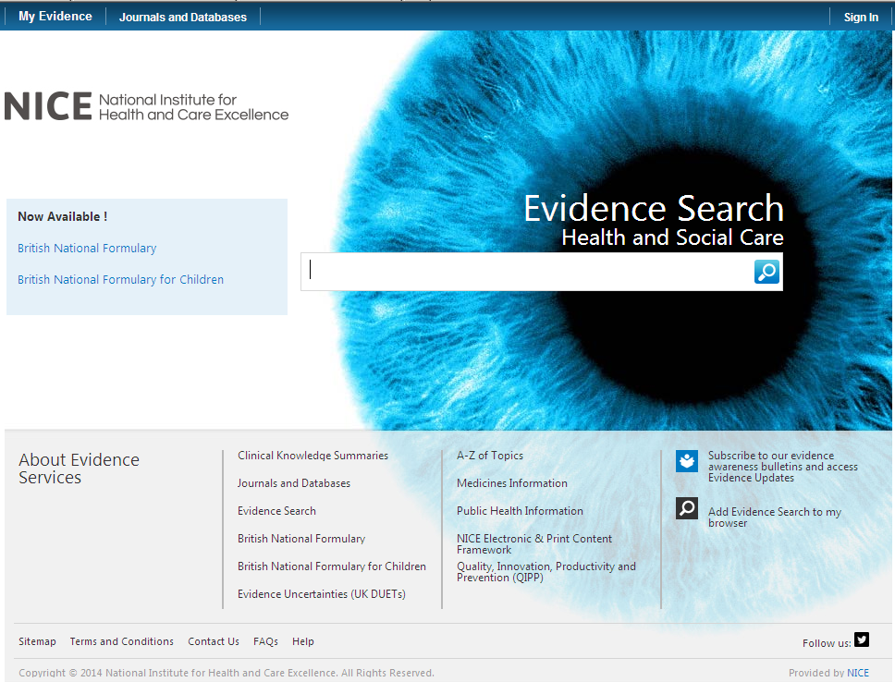

Click on here to sign-in your Athens account

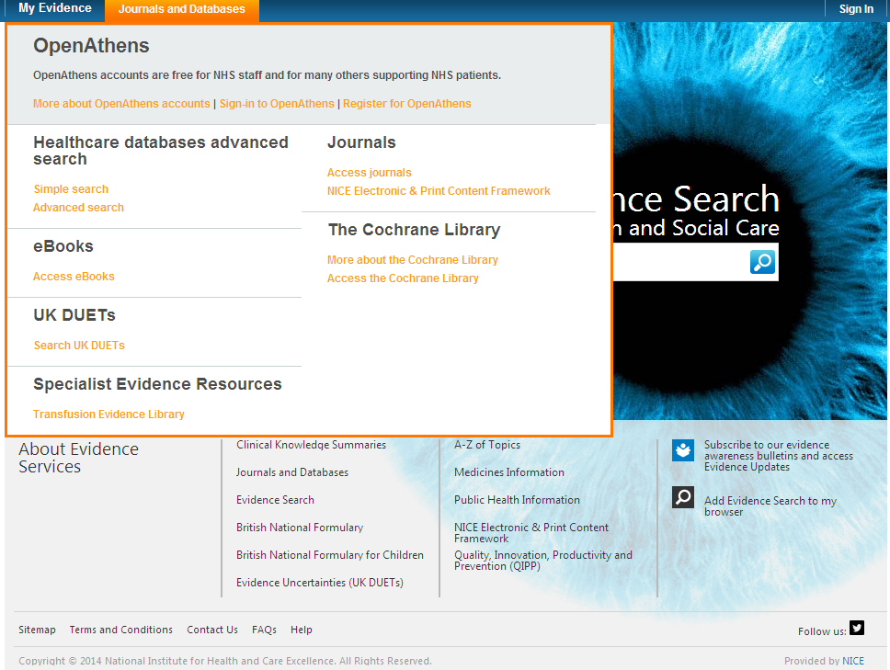

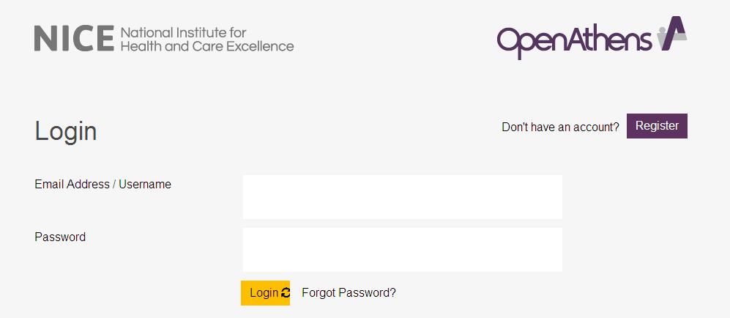

Click on My resources and then click on NICE Journals

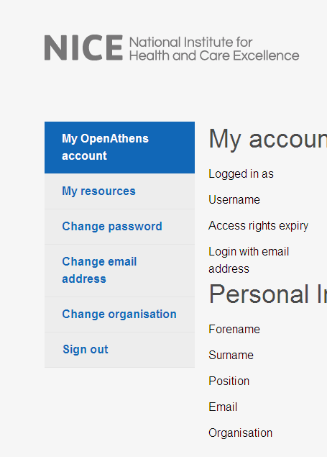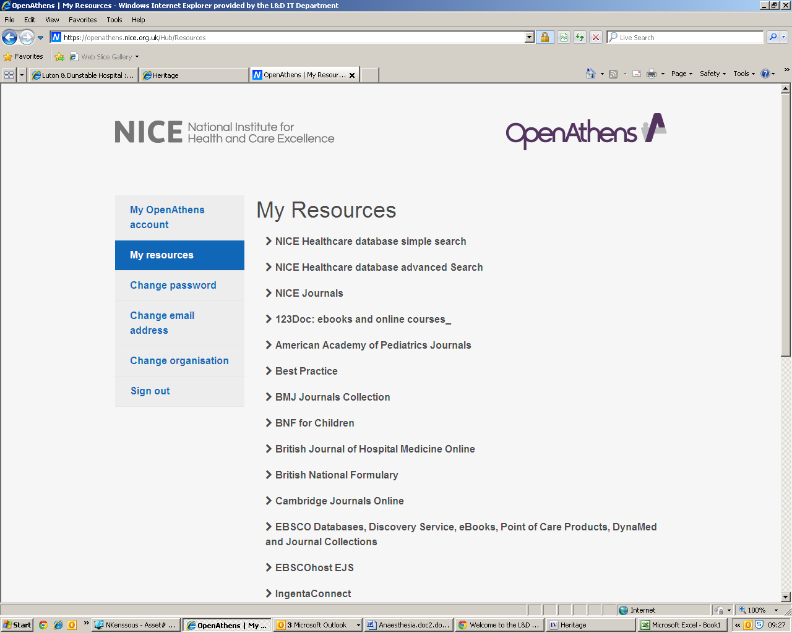

You can browse the A-Z listing, but a more efficient method is to search for the title or keywords from the title of the journal. Enter the title or Key words from the title of the journal you are looking for (e.g. nursing)

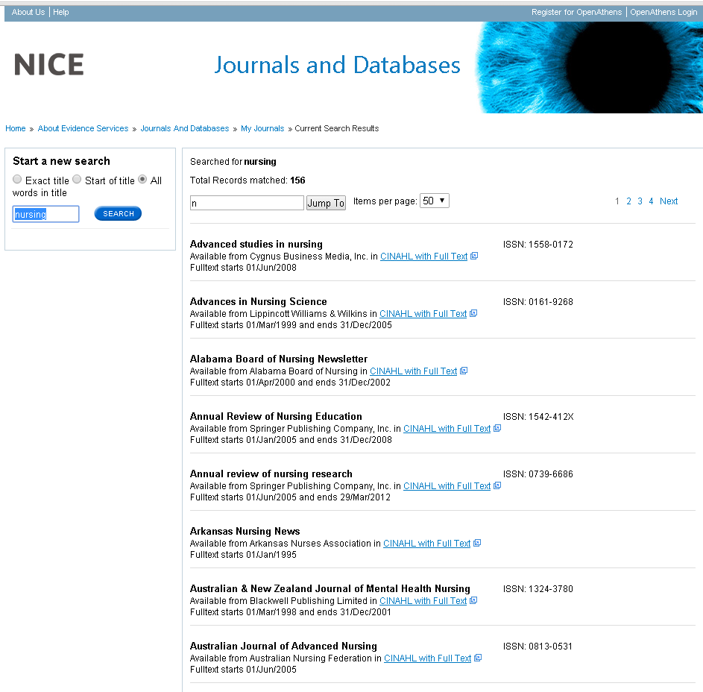

Watch this film for further information on how to access the journals.

- Sources of evidence

Some of the following resources are freely available via www.eel.nhs.uk. Others are accessible with a Luton & Dunstable Hospital NHS Athens account.

BMJ Best Practice (NHS Athens account required)
Point of care resource providing a single source for the latest research evidence, guidelines and expert opinion presented in a step-by-step approach, covering prevention, diagnosis, treatment and prognosis, including additional content from Clinical Evidence. http://bestpractice.bmj.com/best-practice/welcome.html

Cochrane Library
The Cochrane Library is a key source of information on the effects of interventions in health care. It is designed to provide information and evidence to support decisions taken in health care. http://www.thecochranelibrary.com/view/0/index.html

NHS Evidence
Built around a powerful search engine, provides access to the best evidence based resources, especially good for guidelines and reviews. http://www.evidence.nhs.uk/

UptoDate (NHS Athens account required)
A primary resource for medical knowledge at the point of care. UpToDate presents a comprehensive synthesis of the evidence, followed by recommendations that can be acted on at the point of care. http://www.uptodate.com/home

BMJ Case Reports (NHS Athens account required)
An award winning journal that delivers a focused, peer-reviewed, valuable collection of cases in all disciplines so that healthcare professionals, researchers and others can easily find clinically important information on common and rare conditions. Ask the library for the fellowship code if you wish to publish a paper in BMJ Case Reports. http://casereports.bmj.com/

Royal Marsden Manual Online (NHS Athens account required)
The Manual includes over 350 evidence-based clinical procedures related to every aspect of care, from hand washing to cardiopulmonary resuscitation. http://www.rmmonline.co.uk/

NHS Athens accounts
Registering for an Athens account is straightforward, it requires two easy steps: registration and activation. You can begin from the East of England Health Libraries website: www.eel.nhs.uk/ if you register for an Athens account from an NHS computer with an NHS mail address you’ll receive an Athens username straight away. If you register from any other computer, using any other type of email address, it can take longer; up to 15 days in exceptional circumstances as your details need to be verified.

https://register.athensams.net/nhs/nhseng/

The COMET Library

- The COMET Library is located in the main building in Luton and Dunstable Hospital - it is on the first floor of the Centre for Multiprofessional Education and Training.
- It offers a quiet area for study with several study units and easy chair with a suite of fourteen computers which have access to the internet but are not on the NHS network.
- Inductions and full information on library services are offered to all new members.
- There are workshops and one to ones available for literature searching – book an appointment if you are interested.
- You can complete a registration form via the website or you can sign up in person at the library. You will need proof of your employing organisation. Students on placement will need to show their university ID.
  - You can borrow up to eight books at any one time
  - The usual loan period is three week
  - Books can be renewed if no one else wants to borrow them
  - Books can be posted out to your workplace if you are not able to visit

- The library operates a self service unit so items can be borrowed, returned and renewed twenty four seven. But you can also manage your own loans, requests, renewals, with your borrower car, user ID and PIN using the online catalogue.

- You can suggest books for us to buy and request books that are not in stock.
- You do not need to visit the library to borrow resources; we can post items to your workplace.
- You will need an Athens Account to download full text articles but do request items that you cannot obtain for yourself
  - We’ll try and obtain items within the regional network so no direct charges are necessary but if a cost is incurred we will consult you before requesting the book or article.
  - Most requests arrive within a few days of ordering, but if you need your item by a certain date, please tell us this when you make the request.
For more information about The COMET Library call, email or visit our website: www.ldh.nhs.uk/library_services.htm

