The COMET Library

Email: library@ldh.nhs.uk –Tel: 01582 497201

Web: www.ldh.nhs.uk/library_services.htm

Paediatrics
Subject guide: print and electronic resources

- Books

Recently purchased books

Paediatric exams WS 18
Beattie, M. and Champion, M. (eds.) (2012) Essential revision notes in paediatrics for the MRCPCH. 3rd ed. Knutsford, Cheshire: PasTest. 9781905635764

Gill, J., Papanikitas, A. and Kennedy, N. (2012) Get through: DCH clinical. 2nd ed. Boca Raton, FL, USA: CRC Press. 9781444157390

Newell, S.J. and Darling, J.C. (2014) Lecture notes in Paediatrics. 9th ed. Chichester: Wiley. 9780470657072

Paediatrics WS 100
Kapoor, R., Barnes, K. and Bhakthavalsala, S. (2013) Paediatrics. 4th ed. London: Mosby Elsevier. (Crash course). 9780723436355

Lissauer, T. and Clayden, G. (eds.) (2012) Illustrated textbook of paediatrics. 4th ed. Edinburgh: Mosby.

South, M. and Isaacs, D. (2012) Practical paediatrics. 7th ed. London: Churchill Livingstone. 9780702042928

Lissauer, T. and Clayden, G. (eds.) (2012) Illustrated textbook of paediatrics. 4th ed. Edinburgh: Mosby. 9780723435655

Marcdante, K.J. and Kliegman, R. (2015) Nelson essentials of pediatrics. 7th ed. Philadelphia, USA: Elsevier. 9781455759804

Reece, A. and Cohn, A. (eds.) (2014) Clinical cases in paediatrics: a trainee handbook. London: JP Medical Publishers. 9781907816475

South, M. and Isaacs, D. (eds.) (2012) Practical paediatrics. 7th ed. Edinburgh: Churchill Livingstone. 9780702042928

Tasker, R.C., McClure, R.J. and Acerini, C.L. (eds.) (2013) Oxford handbook of paediatrics. 2nd ed. Oxford: Oxford University Press. (Oxford handbooks). 9780199608300

Physical growth WS 103
Gripp, K.W., Slavotinek, A.M. and Hall, J.G. (2013) Handbook of physical measurements. 3rd ed. Oxford: Oxford University Press. 9780199935710

Child development WS 105
Batshaw, M.L., Roizen, N.J. and Lotrecchiano, G.R. (2013) Children with disabilities. 7th ed. Baltimore: Paul H. Brookes Pub. 9781598571943

Boyd, D.R. and Bee, H.L. (2012) The developing child. 13th edn. London: Pearson Education. 9780205844487

British Agencies for Adoption and Fostering, Cairns, K. and Stanway, C. (2013) Learn the child: helping looked after children to learn. 2nd edition London: British Agencies for Adoption and Fostering. 9781907585739

Santrock, J.W. (2013) Adolescence. 14th edn. McGraw Hill. 9781259071232

Turner, P.H., Welch, K. and Hamner, T.J. (2012) Parenting in contemporary society. 5th edn. Boston: Pearson Education. 9780205379033

Child protection, abuse and safeguarding WS 105.5
Blyth, M. and Solomon, E. (eds.) (2012) Effective safeguarding for children and young people: what next after Munro?. Bristol: Policy. 9781447304906

Rushforth, C. (2012) Safeguarding and child protection in the early years. M A Education. 9781907241277

Paediatric Nutrition WS 115
Moran, V.H. (2013) Maternal and infant nutrition and nurture: controversies and challenges. 2nd ed. London: Quay Books. 9781856424356

Paediatric clinical examination WS 141

Hay, W.W. (2012) Current diagnosis & treatment in pediatrics. 21st ed. McGraw Lange. 9780071779708

Paediatric nephrology WS 320
Oh, W., Guignard, J. and Baumgart, S. (2012) Nephrology and fluid/electrolyte physiology: neonatology questions and controversies. 2nd ed. Philadelphia, PA: Saunders/Elsevier. (Neonatology questions and controversies). 9781437726589

Paediatric emergencies WS 205
Crisp, S. and Rainbow, J. (2013) Emergencies in paediatrics and neonatology. 2nd ed. Oxford: OUP. 9780199605538

Location of books in the library Classmark

Paediatric atlases WS 17
Paediatric exams WS 18
Paediatric hospital services WS 27
Paediatric laws WS 32
Paediatrics WS 100
Children's health and welfare WS 101
Physical growth WS 103
Child development WS 105
Child protection, abuse and safeguarding WS 105.5
Neglected children WS 105.6
Domestic violence WS 106
Paediatric nutrition WS 115
Breast feeding WS 125
Paediatric clinical examination WS 141
Child diseases WS 200
Paediatric emergencies WS 205
Paediatric dermatology WS 260
Paediatric orthopaedics WS 270
Paediatric cardiology WS 290
Paediatric oncology WS 300
Paediatric nephrology WS 320
Paediatric urology WS 321
Paediatric endocrinology WS 330
Paediatric neurology WS 340
Cerebral palsy WS 342
Child psychiatry WS 350
Play therapy WS 350.2
Development disorders (CBT) WS 350.6
Adolescence WS 460
Adolescent psychology WS 462

A full list of books on Paediatrics is available from the online library catalogue: http://thecometlibrary.nhslibraries.com/

eBooks (available with NHS Athens account)
These are available through NHS Evidence when logged in with your Athens account, from here: http://www.library.nhs.uk/booksandjournals/ebooks/default.aspx.

- Billson, A.L., Pearce, A.V. and Tuffrey, C., 1998. Key topics in paediatrics. [online]. Taylor & Francis.

- Raine, J. and Walker, J., 2009. 100 cases in paediatrics. [online]. Taylor & Francis.

- Shah, B. and Lucchesi, M., 2006. Atlas of pediatric emergency medicine. [online]. McGraw Hill.

- Waterston, T., Helms, P.J. and Ward-Platt, M., 2006. Paediatrics: a core text on child health. [online]. Radcliffe Publishing.

- Journals

Print journals in the library

Current Paediatrics 1995 to 2006
- Current Opinion in Pediatrics 1993 to 2011

Journal of Pediatrics 2000 to 2002

Pediatric Clinics of North America 1992 to 2011

eJournals (available with Athens account)
- Academic Pediatrics 2009 to 6 months ago
- African Journal of Paediatric Surgery : AJPS 2008 to current issue
- Ambulatory Pediatrics 2004 to 2008

Annals of Pediatric Cardiology 2008 to current issue

Annals of Tropical Paediatrics 1999 to 12 months ago
- Archives of Pediatrics & Adolescent Medicine 1998 to current issue

BMC Pediatrics 2001 to current issue

Brown University Child & Adolescent 1999 to 6 months ago

Canadian Child and Adolescent Psychiatry Review 2003 to 2005

Child and Adolescent Psychiatry & Mental Health 2007 to current issue

Child & Adolescent Psychopharmacology News 2001 to 12 months ago

Child & Adolescent Social Work Journal 2005 to 12 months ago

Child and Family Social Work 1998 to 12 months ago

Child and Youth Care Forum 1997 to 12 months ago

Child: Care, Health and Development 2003 to 12 months ago

Child Development 1965 to 12 months ago

Child Health Alert 2000 to 2010

Child Language Teaching & Therapy 1998 to current issue

Child Neuropsychology 2000 to 18 months ago

Child Psychiatry & Human Development 1997 to 12 months ago

Child Welfare 1990 to current issue

Children and Schools 2001 to current issue

Clinical Child and Family Psychology Review 1998 to 12 months ago

Clinical Pediatrics 1998 to 2005

Contemporary Pediatrics 2006 to current issue

Current Opinion in Pediatrics 1999 to current issue

Developmental Medicine & Child Neurology 2006 to 12 months ago

Education and Treatment of Children 1996 to current issue

European Child & Adolescent Psychiatry 1998 to 12 months ago

European Journal of Pediatrics 1996 to 2009

European Journal of Pediatrics Supplement 1997 to 12 months ago

Exceptional Children 1991 to current issue

Fetal and Pediatric Pathology 2004 to 18 months ago

Future of Children 2006 to current issue

Gifted Child Quarterly 2004 to 2010

Gifted Child Today 1997 to 2011

Indian Journal of Medical and Paediatric Oncology 2009 to 2011

Indian Pediatrics 2007 to 12 months ago

Infants and Young Children 1999 to 2007

Infectious Diseases in Children 2008 to current issue

International Journal of Clinical Pediatric Dentistry 2010 to 2011

International Journal of Pediatric Endocrinology 2009 to current issue

International Journal of Pediatrics 2009 to current issue

Iranian Journal of Pediatrics 2010 to 2011

Issues in Comprehensive Pediatric Nursing 1998 to 18 months ago

Italian Journal of Pediatrics 2008 to current issue

Journal of Abnormal Child Psychology 2004 to 12 months ago

Journal of Child & Adolescent Psychiatric Nursing 1998 to 12 months ago

Journal of Child & Adolescent Psychopharmacology 2000 to 3 months ago

Journal of Child and Family Studies 1997 to 12 months ago

Journal of Child Language 2001 to 12 months ago

Journal of Child Neurology 2001 to 2006

Journal of Child Psychology and Psychiatry 1997 to current issue

Journal of Child Sexual Abuse 2001 to 18 months ago

Journal of Clinical Child & Adolescent Psychology 2002 to 18 months ago

Journal of Clinical Child Psychology 1997 to 2002

Journal of Clinical Research in Pediatric Endocrinology 2008 to current issue

Journal of Developmental & Behavioral Pediatrics 2001 to 2002

Journal of Indian Association of Pediatric Surgeons 2008 to current issue

Journal of Infant, Child, & Adolescent Psychotherapy 2004 to 2009

Journal of Paediatrics and Child Health 1998 to 12 months ago

Journal of Pediatric Gastroenterology & Nutrition 1996 to current issue

Journal of Pediatric Hematology/Oncology 1996 to 2003

Journal of Pediatric Neurology 2004 to 2011

Journal of Pediatric Neurosciences 2009 to 2011

Journal of Pediatric Ophthalmology & Strabismus 1998 to current issue

Journal of Pediatric Orthopaedics 1996 to 2002

Journal of Pediatric Pharmacology & Therapeutics 2010 to 2011

Journal of Pediatric Psychology 1996 to 12 months ago
- Journal of Pediatrics 2003 to current issue

Jnl of the Can Academy of Child & Adolescent Psychiatry 2006 to current issue

Journal of the Society of Pediatric Nurses 1999 to 2001

Journal for Specialists in Pediatric Nursing 2002 to 12 months ago

Korean Journal of Pediatrics 2010 to current issue

Maternal and Child Health Journal 1997 to 12 months ago

MCN, American Journal of Maternal Child Nursing 1996 to 2003

Monographs of the Soc for Research in Child Dev 1965 to 12 months ago

Neonatal, Paediatric and Child Health Nursing 2006 to 6 months ago

New Directions for Child and Adolescent Development 1998 to 12 months ago

Nursing Children and Young People 2002 to current issue

Paediatric Anaesthesia 1998 to current issue

Paediatrics and Child Health 1997 to 12 months ago

Paediatric and Perinatal Epidemiology 1998 to 12 months ago

Paediatric Drugs 2008 to 18 months ago

Paediatric Nursing 2002 to 2011

Paediatrics Today 2008 to 2008

Pediatric Allergy and Immunology 1996 to 12 months ago

Pediatric and Developmental Pathology 2003 to 6 months ago

Pediatric Annals 1998 to current issue

Pediatric Cardiology 2003 to 12 months ago

Pediatric Clinics of North America 1996 to current issue

Pediatric Dermatology 1983 to 12 months ago

Pediatric Diabetes 2003 to 12 months ago

Pediatric Drugs 1999 to 6 months ago

Pediatric Emergency Medicine Reports 2008 to current issue

Pediatric Endocrinology, Diabetes & Metabolism 2007 to current issue

Pediatric Health 2007 to 2010

Pediatric Hematology and Oncology 1998 to 18 months ago

Pediatric Infectious Disease Journal 1996 to current issue

Pediatric Nephrology 1996 to 12 months ago

Pediatric Neurosurgery 1998 to 12 months ago

Pediatric Nursing 1999 to current issue

Pediatric Pathology & Molecular Medicine 2001 to 2003

Pediatric Radiology 2000 to 12 months ago

Pediatric Rehabilitation 1999 to 2006

Pediatric Research 1996 to current issue

Pediatric Rheumatology 2007 to current issue

Pediatric Surgery International 2000 to 12 months ago

Pediatric Transplantation 1999 to 12 months ago

Pediatrics for Parents 1998 to 2011

Pediatrics International 1998 to 12 months ago

Pediatrics 1948 to current issue

Pediatrics Week 2008 to current issue

Physical & Occupational Therapy in Pediatrics 2001 to 18 months ago

Paediatrics and Child Health 2007 to current issue

Psychoanalytical Study of the Child 2007 to 2009

Reclaiming Children and Youth 1998 to 2011

Turkish Journal of Pediatrics 2007 to current issue

eJournals (available with NHS Athens account)

These are available through NHS Evidence when logged in with your Athens account, from here: http://www.library.nhs.uk/booksandjournals/journals/

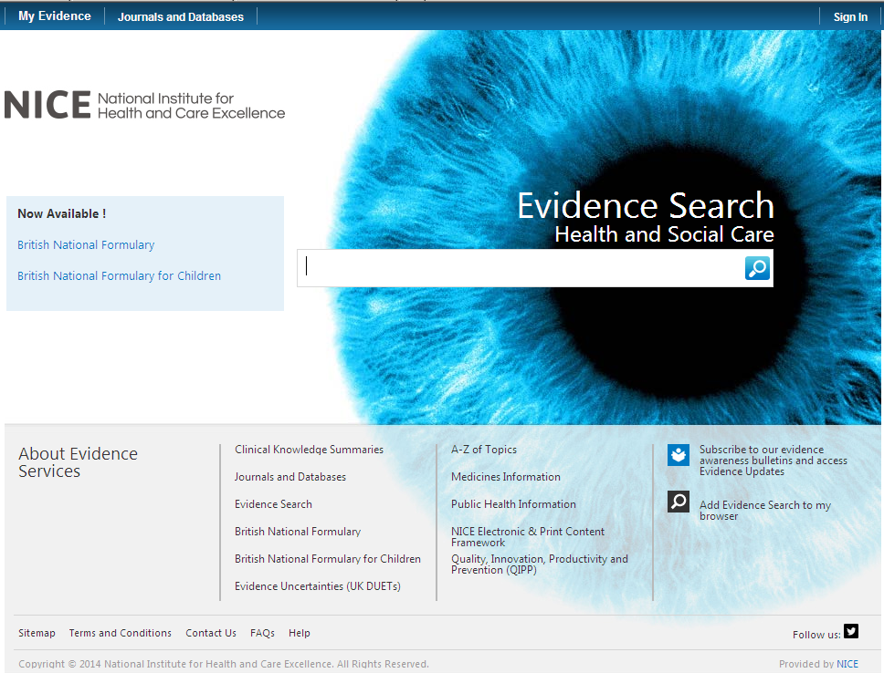

Click on here to sign-in your Athens account

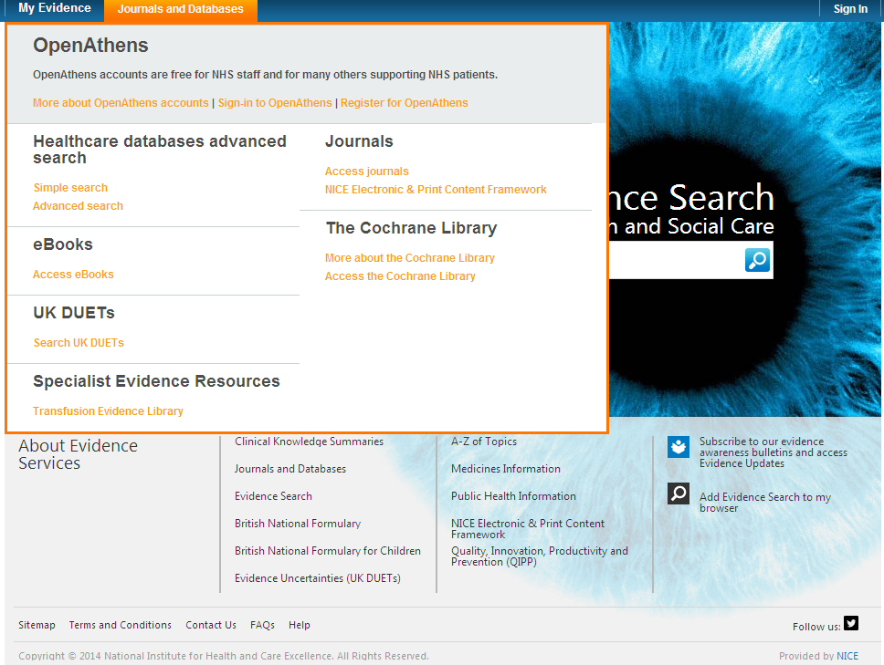

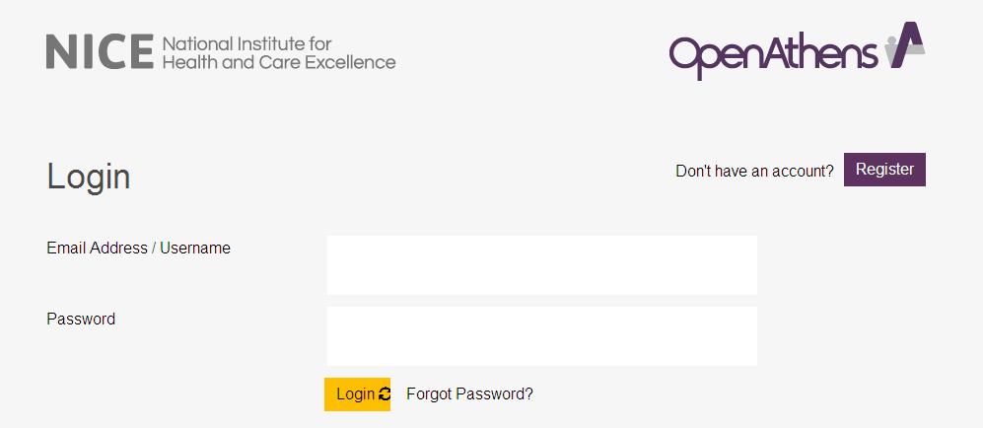

Click on My resources and then click on NICE Journals

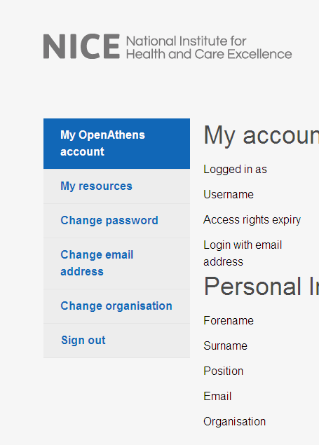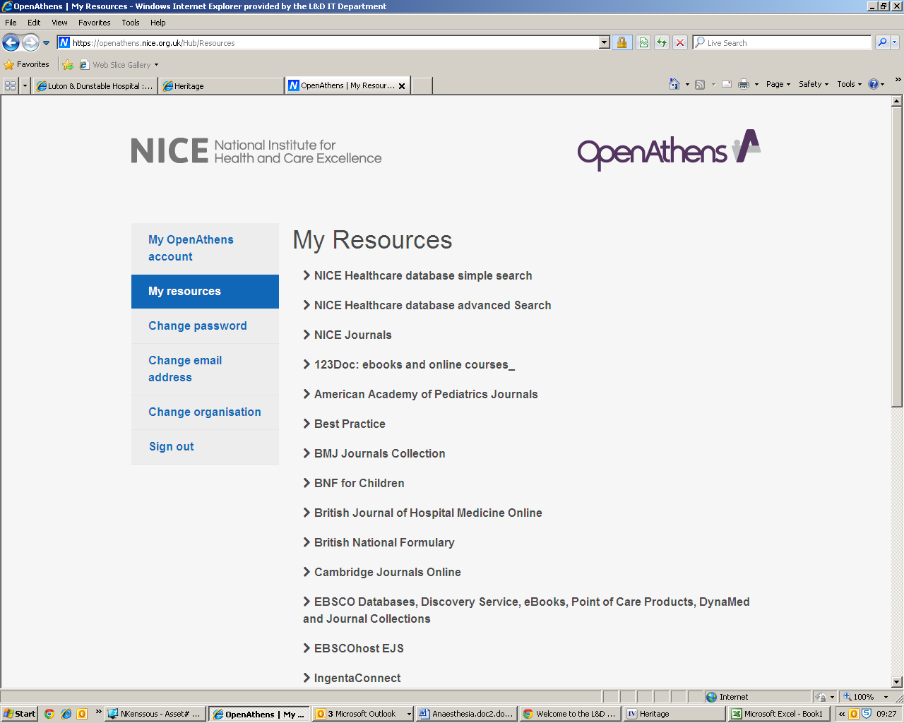

You can browse the A-Z listing, but a more efficient method is to search for the title or keywords from the title of the journal. Enter the title or Key words from the title of the journal you are looking for (e.g. paediatric OR pediatric)

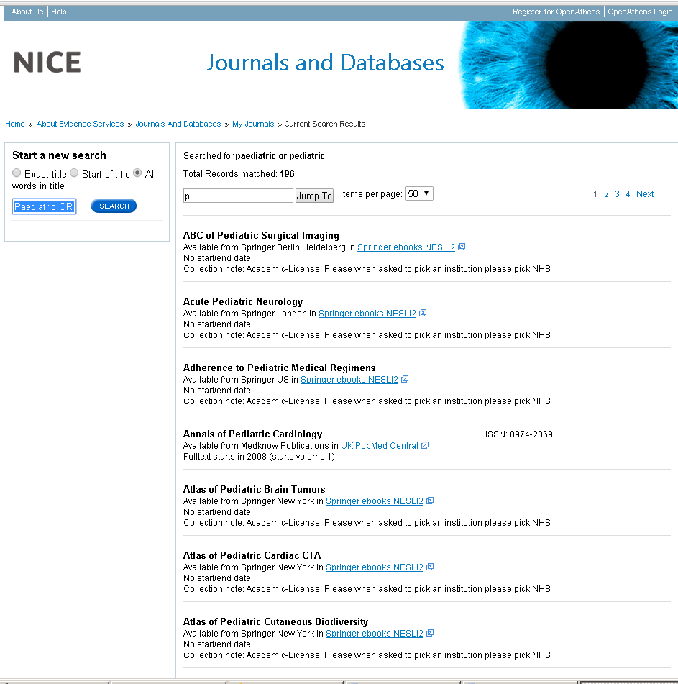

Watch this film for further information on how to access the journals.

- Sources of evidence

Some of the following resources are freely available via www.eel.nhs.uk. Others are accessible with a Luton & Dunstable Hospital NHS Athens account.

BMJ Best Practice (NHS Athens account required)
Point of care resource providing a single source for the latest research evidence, guidelines and expert opinion presented in a step-by-step approach, covering prevention, diagnosis, treatment and prognosis, including additional content from Clinical Evidence. http://bestpractice.bmj.com/best-practice/welcome.html

Cochrane Library
The Cochrane Library is a key source of information on the effects of interventions in health care. It is designed to provide information and evidence to support decisions taken in health care. http://www.thecochranelibrary.com/view/0/index.html

NHS Evidence
Built around a powerful search engine, provides access to the best evidence based resources, especially good for guidelines and reviews. http://www.evidence.nhs.uk/

UptoDate (NHS Athens account required)
A primary resource for medical knowledge at the point of care. UpToDate presents a comprehensive synthesis of the evidence, followed by recommendations that can be acted on at the point of care. http://www.uptodate.com/home

BMJ Case Reports (NHS Athens account required)
An award winning journal that delivers a focused, peer-reviewed, valuable collection of cases in all disciplines so that healthcare professionals, researchers and others can easily find clinically important information on common and rare conditions. Ask the library for the fellowship code if you wish to publish a paper in BMJ Case Reports. http://casereports.bmj.com/

Royal Marsden Manual Online (NHS Athens account required)
The Manual includes over 350 evidence-based clinical procedures related to every aspect of care, from hand washing to cardiopulmonary resuscitation. http://www.rmmonline.co.uk/

NHS Athens accounts
Registering for an Athens account is straightforward, it requires two easy steps: registration and activation. You can begin from the East of England Health Libraries website: www.eel.nhs.uk/ if you register for an Athens account from an NHS computer with an NHS mail address you’ll receive an Athens username straight away. If you register from any other computer, using any other type of email address, it can take longer; up to 15 days in exceptional circumstances as your details need to be verified.
https://register.athensams.net/nhs/nhseng/
The COMET Library

- The COMET Library is located in the main building in Luton and Dunstable Hospital - it is on the first floor of the Centre for Multiprofessional Education and Training.
- It offers a quiet area for study with several study units and easy chair with a suite of fourteen computers which have access to the internet but are not on the NHS network.
- Inductions and full information on library services are offered to all new members.
- There are workshops and one to ones available for literature searching – book an appointment if you are interested.
- You can complete a registration form via the website or you can sign up in person at the library. You will need proof of your employing organisation. Students on placement will need to show their university ID.
  - You can borrow up to eight books at any one time
  - The usual loan period is three week
  - Books can be renewed if no one else wants to borrow them
  - Books can be posted out to your workplace if you are not able to visit

- The library operates a self service unit so items can be borrowed, returned and renewed twenty four seven. But you can also manage your own loans, requests, renewals, with your borrower car, user ID and PIN using the online catalogue.

- You can suggest books for us to buy and request books that are not in stock.
- You do not need to visit the library to borrow resources; we can post items to your workplace.
- You will need an Athens Account to download full text articles but do request items that you cannot obtain for yourself
  - We’ll try and obtain items within the regional network so no direct charges are necessary but if a cost is incurred we will consult you before requesting the book or article.
  - Most requests arrive within a few days of ordering, but if you need your item by a certain date, please tell us this when you make the request.
For more information about The COMET Library call, email or visit our website: www.ldh.nhs.uk/library_services.htm

