The COMET Library

Email: library@ldh.nhs.uk –Tel: 01582 497201

Web: www.ldh.nhs.uk/library_services.htm

Undertaking Research – start here…
Subject guide: print and electronic resources

- Books

Recently purchased books

Research (Using Evidence) W 20.5
Bryman, A. (2012) Social research methods. 4th ed. Oxford: Oxford University Press.
9780199588053

Cooper, S. and Patton, R. (2012) Writing logically, thinking critically. 7th ed. Boston: Pearson.
9780205119127

Green, J. and Thorogood, N. (2014) Qualitative methods for health research. 3rd ed. London: Sage.9781446253090

Hall, G.M. (ed.) (2013) How to write a paper. 5th ed. Chichester: John Wiley & Sons.
9780470672204

Hochman, M.E. (2014) 50 studies every doctor should know: the key studies that form the foundation of evidence based medicine. Rev. ed. Oxford: Oxford University Press.
9780199343560

Evidence-based practice W 22
Aveyard, H. and Sharp, P. (2013) A beginner's guide to evidence-based practice in health and social care. 2nd ed. Maidenhead: Open University Press.
9780335246724

Ellis, P. (2013) Evidence-based practice in nursing. 2nd ed. London: SAGE.
9781446270905

Critical appraisal W 25
Gosall, N. and Gosall, G.S. (2012) The doctors guide to critical appraisal. 3rd ed. PasTest.
9781905635818

Audit and evaluation W 84
Medicines and Healthcare Products Regulatory Agency (2012) Good clinical practice guide. London: H.M.S.O. 9780117081079

Data collection WA 950
Fink, A. (2013) How to conduct surveys : a step-by-step guide. 5th ed. Los Angeles: SAGE.
9781452203874

Hamilton, P. (2012) Data interpretation for medical students. 2nd ed. Cheshire: Pastest.
9781905635771

Pallant, J. (2013) SPSS survival manual: a step by step guide to data analysis using IBM SPSS. 5th edn. Maidenhead: Open University Press. 9780335262588

Location of books in the library Calssmark
Research using evidence W 20.5
Evidence based practice W 22
Clinical reasoning W 23
Critical appraisal W 25
Audit, evaluation and trials W 84
Data collection WA950

A full list of books on Research, audit, critical appraisal and data collection are available from the online library catalogue: http://thecometlibrary.nhslibraries.com/

eBooks (available with NHS Athens account)
These are available through NHS Evidence when logged in with your Athens account, from here: http://www.library.nhs.uk/booksandjournals/ebooks/default.aspx.

- Latimer, J., 2009. Advanced qualitative research for nursing. [online]. Wiley-Blackwell. 9781405149983
- Gao-Smith, F. and Smith, J.E., 2002. Key topics in clinical research: a user guide to researching, analysing and publishing clinical data. [online]. Taylor & Francis. 9780203450307
- Smith Iltis, A., 2012. Research ethics. [online]. Routledge.
9781135991500
- Hartung, J., Knapp, G. and Sinha, B.K., 2008. Statistical meta analysis with applications. [online]. Wiley-interscience. 9780470386330

Journals

eJournals (available with NHS Athens account)

These are available through NHS Evidence when logged in with your Athens account, from here: http://www.library.nhs.uk/booksandjournals/journals/

BMC Medical Research Methodology 2001 to present

Clinical Evidence 2003 and ends 24 months ago

Evidence Based Midwifery 2011 to present

Evidence-Based Nursing 1998 - to present

Evidence-Based Medicine 2000 to present

Evidence-Based Mental Health 1998 to present

Evidence-Based Nursing 1998 to present

Journal of Evidence - Based Psychotherapies 2006 - to present

Worldviews on evidence-based nursing 2004 - 2013

Trials 2000 to present

eJournals (available with NHS Athens account)

These are available through NHS Evidence when logged in with your Athens account, from here: http://www.library.nhs.uk/booksandjournals/journals/

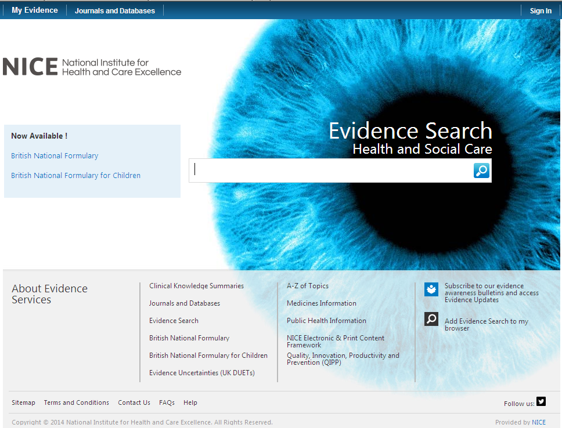

Click on here to sign-in your Athens account

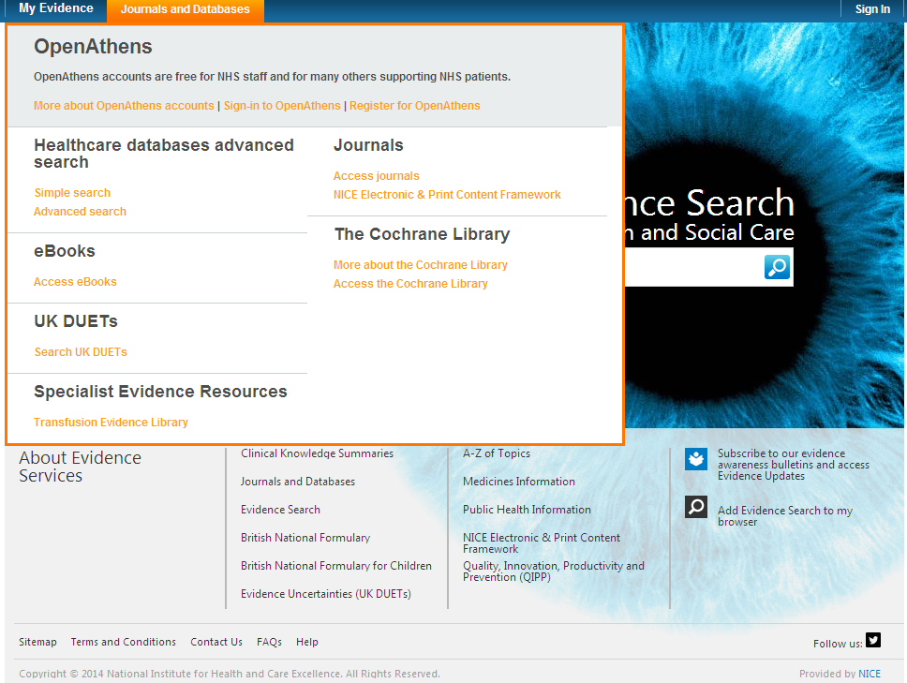

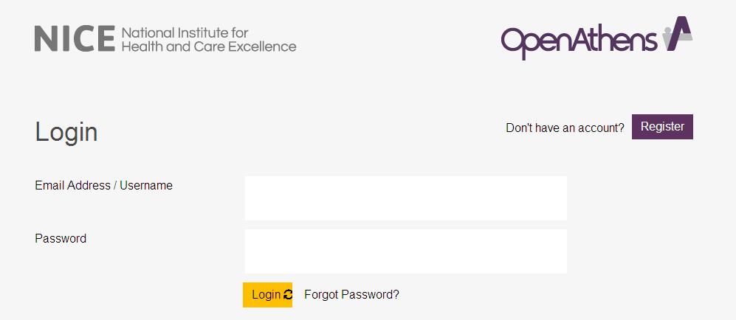

Click on My resources and then click on NICE Journals

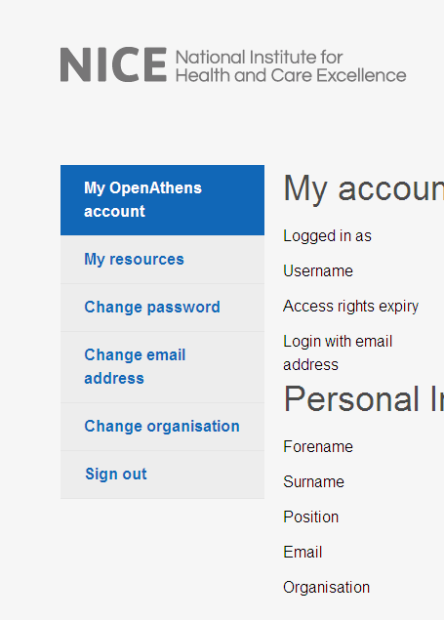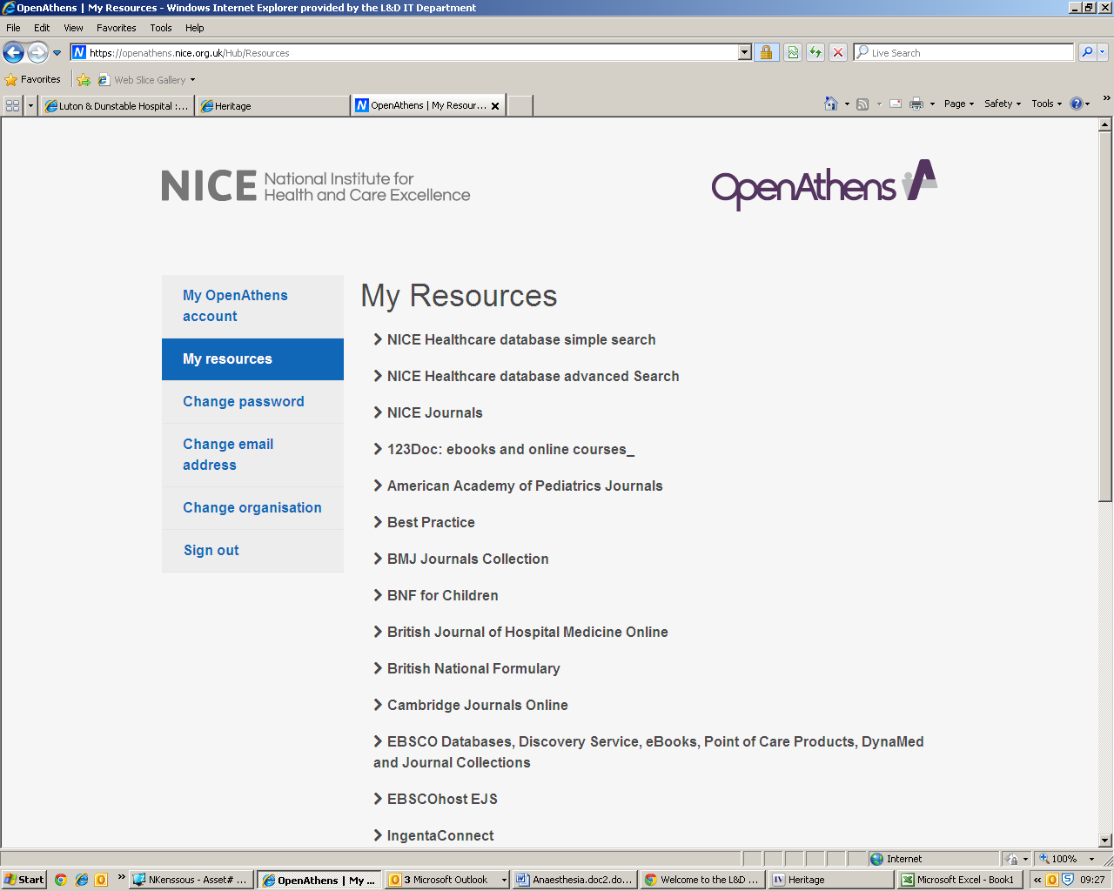

You can browse the A-Z listing, but a more efficient method is to search for the title or keywords from the title of the journal. Enter the title or Key words from the title of the journal you are looking for (e.g. Research OR Critical Appraisal)

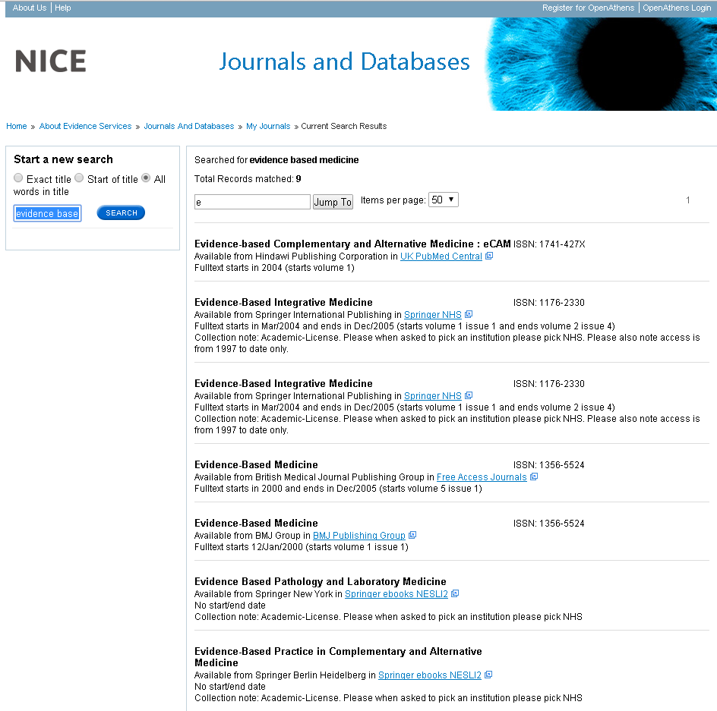

Watch this film for further information on how to access the journals.

- Sources of evidence

Some of the following resources are freely available via www.eel.nhs.uk. Others are accessible with a Luton & Dunstable Hospital NHS Athens account.

BMJ Best Practice (NHS Athens account required)
Point of care resource providing a single source for the latest research evidence, guidelines and expert opinion presented in a step-by-step approach, covering prevention, diagnosis, treatment and prognosis, including additional content from Clinical Evidence. http://bestpractice.bmj.com/best-practice/welcome.html

Cochrane Library
The Cochrane Library is a key source of information on the effects of interventions in health care. It is designed to provide information and evidence to support decisions taken in health care. http://www.thecochranelibrary.com/view/0/index.html

NHS Evidence
Built around a powerful search engine, provides access to the best evidence based resources, especially good for guidelines and reviews. http://www.evidence.nhs.uk/

UptoDate (NHS Athens account required)
A primary resource for medical knowledge at the point of care. UpToDate presents a comprehensive synthesis of the evidence, followed by recommendations that can be acted on at the point of care. http://www.uptodate.com/home

BMJ Case Reports (NHS Athens account required)
An award winning journal that delivers a focused, peer-reviewed, valuable collection of cases in all disciplines so that healthcare professionals, researchers and others can easily find clinically important information on common and rare conditions. Ask the library for the fellowship code if you wish to publish a paper in BMJ Case Reports. http://casereports.bmj.com/

Royal Marsden Manual Online (NHS Athens account required)
The Manual includes over 350 evidence-based clinical procedures related to every aspect of care, from hand washing to cardiopulmonary resuscitation. http://www.rmmonline.co.uk/

NHS Athens accounts
Registering for an Athens account is straightforward, it requires two easy steps: registration and activation. You can begin from the East of England Health Libraries website: www.eel.nhs.uk/ if you register for an Athens account from an NHS computer with an NHS mail address you’ll receive an Athens username straight away. If you register from any other computer, using any other type of email address, it can take longer; up to 15 days in exceptional circumstances as your details need to be verified.
https://register.athensams.net/nhs/nhseng/
The COMET Library

- The COMET Library is located in the main building in Luton and Dunstable Hospital - it is on the first floor of the Centre for Multiprofessional Education and Training.
- It offers a quiet area for study with several study units and easy chair with a suite of fourteen computers which have access to the internet but are not on the NHS network.
- Inductions and full information on library services are offered to all new members.
- There are workshops and one to ones available for literature searching – book an appointment if you are interested.
- You can complete a registration form via the website or you can sign up in person at the library. You will need proof of your employing organisation. Students on placement will need to show their university ID.
  - You can borrow up to eight books at any one time
  - The usual loan period is three week
  - Books can be renewed if no one else wants to borrow them
  - Books can be posted out to your workplace if you are not able to visit

- The library operates a self service unit so items can be borrowed, returned and renewed twenty four seven. But you can also manage your own loans, requests, renewals, with your borrower car, user ID and PIN using the online catalogue.

- You can suggest books for us to buy and request books that are not in stock.
- You do not need to visit the library to borrow resources; we can post items to your workplace.
- You will need an Athens Account to download full text articles but do request items that you cannot obtain for yourself
  - We’ll try and obtain items within the regional network so no direct charges are necessary but if a cost is incurred we will consult you before requesting the book or article.
  - Most requests arrive within a few days of ordering, but if you need your item by a certain date, please tell us this when you make the request.
For more information about The COMET Library call, email or visit our website: www.ldh.nhs.uk/library_services.htm

