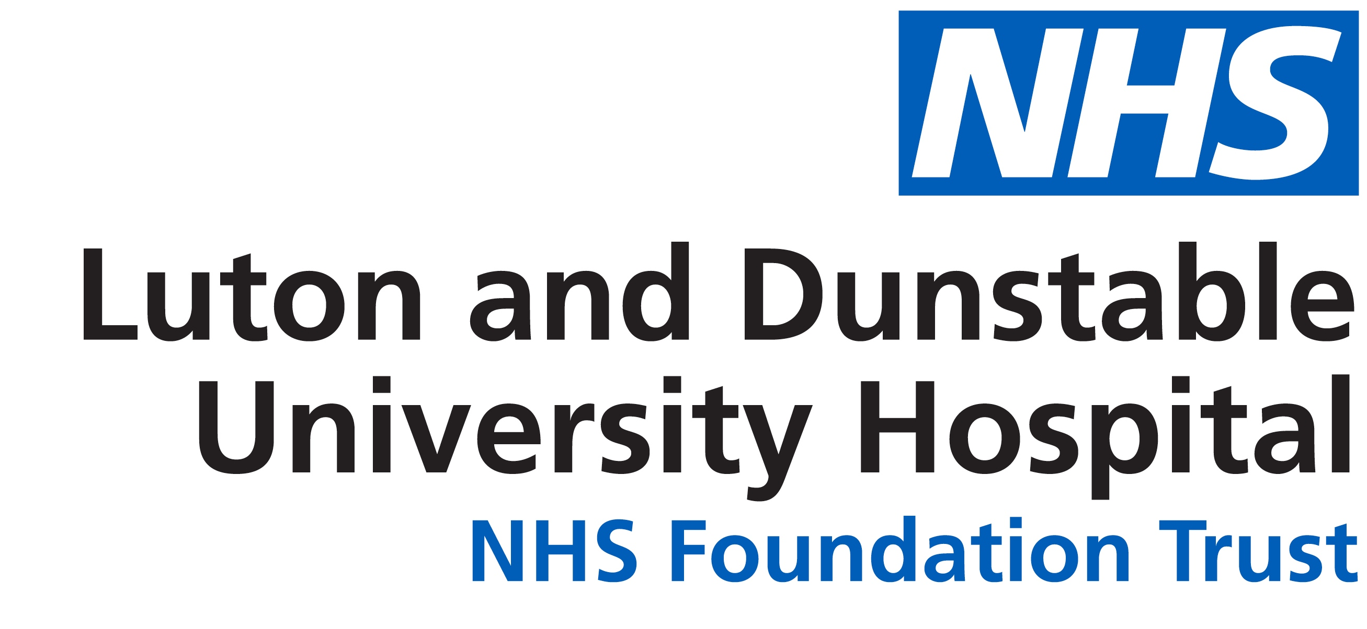
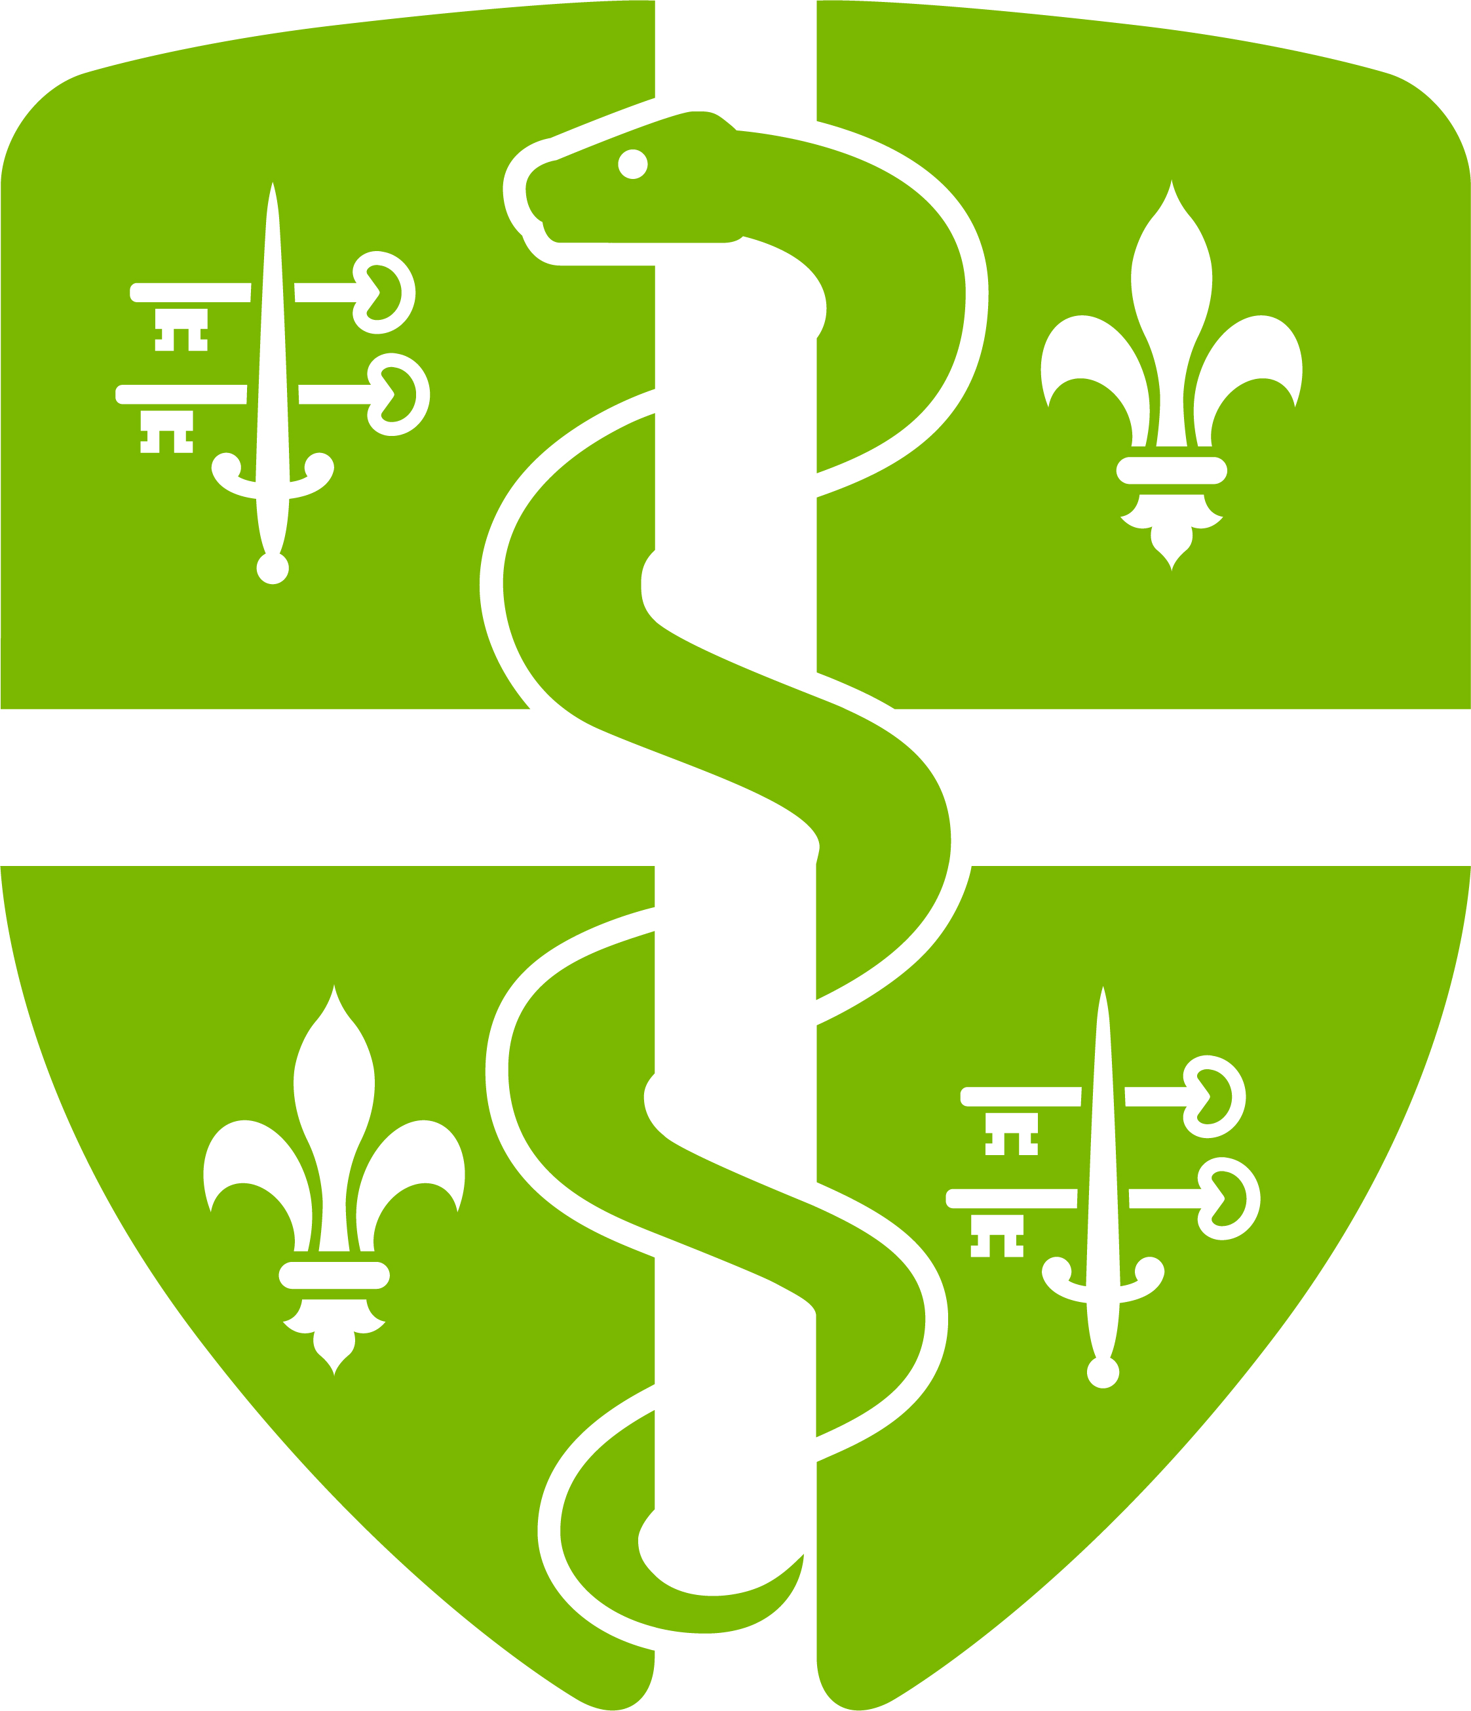
Information for GPs regarding IDDSI
What is IDDSI?
Dysphagia is the medical term for swallowing difficulties and a sign or symptom of disease, which may be neurological, muscular, physiological or structural. Dysphagia affects people of all ages in all types of care setting. Food and fluid modification is widely accepted as a way to manage dysphagia. Local variations have persisted for both food and fluid textures confusing patients, carers and healthcare staff. The imprecise term ‘soft diet’ continues to be used to refer to modified food texture for patients with and without dysphagia.
In June 2018 NHS Improvement issued the Patient Safety Alert Resources to support safer modification of food and drink. A review of National Reporting and Learning System over a 2 year period identified seven reports where patients have come to significant harm because of confusion about the meaning of the term “soft diet”. These incidents included choking and aspiration pneumonia; two patients died, and suggested that the continuing use of the term ‘soft diet’ can lead to patients needing a particular type of modified diet being harmed.
As a result, the International Dysphagia Diet Standardisation Initiative (IDDSI) developed standard terminology to describe texture modification for food and drink. The over-riding goal of IDDSI is patient safety, ensuring safety through common terminology for all ages in all care settings and for all cultures.
How will it impact you?
The transition to IDDSI diet and fluid textures should have been completed by 1 April 2019. Within Luton and Dunstable Hospital we have already implemented the use of IDDSI terminology for fluid recommendations (levels 0 – 4) and the IDDSI diet descriptors are now fully in place as of 1st April 2019 in line with recommendations from NHS Improvement.
The Speech and Language Therapy team will now be making recommendations using the IDDSI levels which will be included in all reports and handovers.
However, as per the Patient Safety Alert, IDDSI food texture descriptors also need to be adopted for patients who do not have dysphagia but for other clinical reasons need a modified texture diet (e.g. secondary to head and neck/gastro surgery, lack of dentition). For these patients, SLT may not be involved and therefore recommendations for specific diet textures may come from nurses or doctors.
In the past, for these patients they are sometimes recommended to have a ‘soft diet’. As SLTs we have experienced confusion when recommendations are made for soft diet – some people refer to soft diet as puree, others as soft options of normal diet and everything in between. We now all need to be speaking the same language to improve patient safety and reduce risks and we are now asking you to refer to the specific IDDSI level in your recommendations.
There are posters available from Speech & Language Therapy describing the different fluid and diet levels. Lanyard cards are also available for nurses and doctors as a quick reference tool.

IDDSI LEVEL | DESCRIPTION
FLUIDS
Level 0 | Normal fluids
Level 1 (slightly thick) | 1 scoop Resource Thicken Up Clear per 200ml
Level 2 (mildly thick) | 2 scoops Resource Thicken Up Clear per 200ml
Level 3 (moderately thick) | 4 scoops Resource Thicken Up Clear per 200ml
Level 4 (extremely thick) | 8 scoops Resource Thicken Up Clear per 200ml
FOOD Don’t just take the soft option!
Level 3 Liquidised | Soft, no lumps, can be eaten from a spoon or drunk from a cup, no chewing required
Level 4 Pureed | Smooth with no lumps, not sticky, no chewing required, holds shape on a plate, can be eaten with a spoon
Level 5 Minced and Moist | Very soft, small moist lumps with no separate thin liquid. Minimal chewing required
Level 6 Soft and Bite-Sized | Soft, tender and moist throughout, with no separate thin liquid. ‘Bite-sized’ pieces (no bigger than 1.5 cm x 1.5 cm) that require chewing
Level 7 Regular easy to chew | Normal, everyday foods of soft/tender texture. Food piece size is unrestricted
Level 7 Regular | No texture restrictions

For further information:
- Visit www.IDDSI.org
- Download the free IDDSI App for both iOS and Android devices. The app contains videos and all information about the framework. Once the app has been downloaded the videos continue to work without the need for wifi or data access.
- Contact SLT directly on 01582 497049. As a team we would be happy to deliver further IDDSI training if requested

